CHEMICAL ADVANCEMENTS IN RUST AND CORROSION SOLUTIONS COULD SAVE AUTOMOTIVE INDUSTRY MILLIONS

Photo credit: Ramiro Mendes

Sydney, Australia: 9/5/19

To auto mechanics, rust is the enemy. But few people realise the immense impact it has across the nation. Curtin University research has shown that the cost of rust and corrosion could be costing Australia up to $32 billion each year.

“Most decision makers do not realise that corrosion is a significant problem,” said Professor Rolf Gubner, Director of the WA Corrosion Research Group. “Timely, well-planned action on corrosion is one way that we can improve the efficiency of our economy. Besides saving money, doing this can also help prevent horrible accidents.”

Those on the frontline combatting rust may well know the dangers, but without access to the latest in chemical advancements, automotive businesses are spending unnecessary time and money to treat and prevent corrosion.

Aware of the huge costs to the automotive industry, NCH chemists took on the challenge to create solutions that were both effective and safe to use. The solutions they came up with combined the latest research and technology to formulate a range of chemical solutions for the management of rust & corrosion.

In the automotive industry, this process is integral in de-rusting parts during vehicle restoration or parts that have developed rust during storage and can also be used to de-rust tools. The NCH three-step process not only treats rust but also prevents it from returning, saving Australian automotive businesses millions.

Already renowned for their industrial degreasers, the first step is to remove contaminants from all parts. The second step involves their patented X-Rust 7, a ground-breaking pH neutral system that is safe and environmentally friendly. It works at room temperature to remove tarnish and rust from carbon steel, mild steel, cast iron and other metals, inhibiting flash rusting. After soaking the part for between 15 minutes and 24 hours, depending on the severity of the rust, parts come out as good as new.
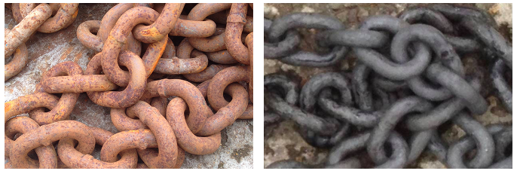
Before After

For parts that cannot be immersed, they have introduced X-Rust 7 Gel, which can be rubbed onto the metal and works the same way as the original product. Ideal for vehicle bodywork, and machinery, it completely removes even deep rust in 24 hours.

Once the rust is removed, NCH offers a range of solutions to coat and protect the affected parts to prevent rust from returning.

Tackling the problem of the most dangerous corrosion which occurs in steel structures like pipe-work, pressure vessels, suspended walkways and cranes, they introduced a new hybrid rust-encapsulator called Salvage 2+. It encapsulates and seals with a top coat in a single coat, and its outstanding corrosion resistance stands up to the 3000-hour scribed hot salt spray test.

Wherever corrosion occurs, it has the potential to cost businesses money and even endanger lives. The advancements in treatment, if properly adopted by industry could save the Australian economy billions.

About NCH

To see X-Rust 7 in action, see our video on how it works here. To find out more about NCH Australia and its solutions, visit the NCH Website or contact NCH by clicking here.

Press Contact
Caryanne Cleevely
Caryanne.cleevely@nch.com
02 9669 0208

