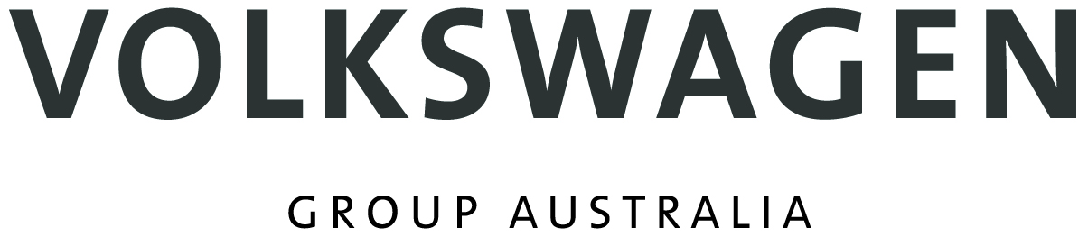

Volkswagen Group Australia Pty Ltd
24 Muir Road
Chullora NSW 2190
ABN 14 093 117 876
Phone (02) 9695 6000

Thursday March 14, 2019

South Australian dealers named Volkswagen’s best

Duttons Volkswagen at Totness and Southern Volkswagen at Reynella have been recognized as the two best Volkswagen dealers of more than 100 in Australia.

At the top-selling European brand’s Premium Dealer awards, Duttons scored the unique double of being named both Volkswagen’s National and Rural Dealer of the year.

Southern Volkswagen was named Provincial Dealer of the year. Each year only 10 dealerships achieve Premium Dealer recognition.

Duttons and Southern both achieved a “balanced score card, not merely sales results, reflecting our brand’s commitment to quality across the entire customer experience,” said Volkswagen Australia’s Director of Customer experience and Marketing Jason Bradshaw.

“Since 2016 we have taken 400,000 responses to our Customer Sales and Aftersales experience survey,” Mr Bradshaw said. “Customer feedback confirms that programs like the Experience Summit have translated to meaningful improvements.

“Independent studies like JD Powers Sales Satisfaction Index also shows improvement, specifically a six position improvement in rank year-on-year.

“Volkswagen remains the only automotive brand to publish on its find-a-dealer website the performance of its dealerships as measured by customers, by displaying an easy to understand star rating for every dealership across sales and aftersales.”

Paul Pottinger, General Manager Corporate Communications

Tel (02) 9695 6196 Mobile 0434 755 158

Kurt McGuiness, Public Relations and Brand Experience Manager

Tel (02) 9695 6198 Mobile 0413 135 334

