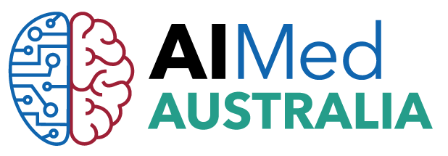

AIMed a global influential technology healthcare community launch AIMed Australia in Sydney this November.
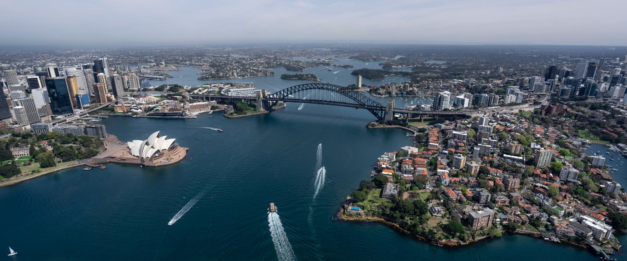

AIMed is a leading provider of global clinician-led artificial intelligence events, education and editorial content in healthcare and medicine.
This November, Australia will be part of the AIMed global community, joining AIMed Europe, AIMed Asia and AIMed North America. AIMed’s vision is to bring about a revolution that embraces a new paradigm of medicine and healthcare propelled by artificial intelligence.

“AIMed has been yearning to be in Australia as some of the World’s best minds in informatics and intelligence in biomedicine are in that region. In order to be excellent at AI in medicine and healthcare, we need to learn about each country’s health system, AI landscape, and how they solve problems using AI. We very much look forward to this exciting opportunity to learn from each other”. AIMed Chairman and Founder, Chief Intelligence and Innovation Officer of Children’s Hospital of Orange County (CHOC) Dr. Anthony Chang.

What makes AIMed Australia Different?

AIMed Australia 2019 is for those interested in the biggest paradigm shift in healthcare and medicine: Artificial Intelligence. An interactive platform designed by clinicians to showcase latest thinking and facilitate new ideas and partnerships. It’s an opportunity to immerse in new ideas and innovative solutions connected to the evolution of AI in medicine and healthcare.
Simply put, its content is developed by clinicians for clinicians.

Dr. Tim Smtyh, Health Management Consultant, Practice Principal Health Sector Law and Board Chair Western NSW Primary Health Network commented that it’s no surprise that AIMed has chosen to launch in Sydney this coming November, he comments.

“Ranked in the top three health systems worldwide, Australia is a leader in medical research and is forging a strong partnership in innovation across computing, technology, data analytics and bioengineering. So, it’s not a surprise that AIMed has chosen to launch in Sydney this coming November. There is much to discuss and learn, and I look forward to the exchange of ideas and experiences among health industry technology experts and clinicians at this leading conference.”
Dr Tim Smyth,

Keep in touch for the latest updates

Luli Adeyemo  Managing Director  Best Case Scenario Event Management  0415 209334 / 02 8060 8398  luli@bestcasescenario.com.au  www.bestcasescenario.com.au  https://aimed.events/aimed-australia-2019/ | Freddy White  CEO  AIMed  +44 796 8565 401  freddy@ai-med.io

