Aussies can now buy a low-cost household disinfectant proven to kill COVID-19

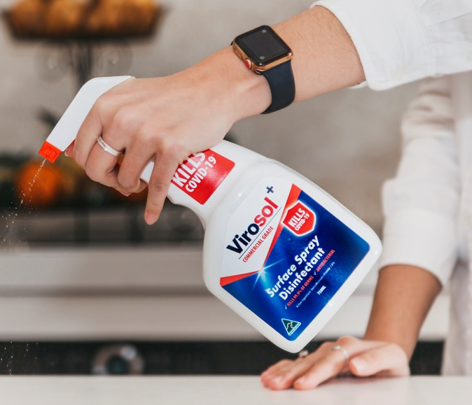
From today, Australian consumers can purchase a locally produced, low-cost household surface spray disinfectant proven to kill SARS CoV-2 (COVID-19), as another line of defence against the spread of COVID-19 in homes and businesses.

One hundred per cent Australian-owned and manufactured, Virosol+ by 1TEK Biosafe is entered in the Australian Register of Therapeutic Goods (ARTG), number AUST L 341 775.

Virosol+ household surface spray disinfectant is available now from www.virosol.com.au at a cost of $11.95 per 750ml spray bottle, with larger sizes also available.

1TEK Biosafe CEO, Sophie Westlake, applauded the decision to have Virosol+ entered in the Australian Register of Therapeutic Goods (ARTG), number AUST L 341 775, assuring consumers of the product’s efficacy.

“This is an important step in the fight against COVID-19 for Australian consumers and small businesses. We know the coronavirus can linger on hard, non-porous surfaces around the home or workplace, like door handles, keyboards, phone cases and lift buttons.

“Families and small business owners need a low-cost, easy-to-use surface spray disinfectant that they know is effective. When used as directed, Virosol+ is proven to kill COVID-19 and 99.9 per cent of bacteria. As Virosol+ is made locally by 1TEK Biosafe, it reduces the potential for supply issues often experienced with products coming from overseas,” said Ms Westlake.

She said the product was non-flammable and “couldn’t be easier to use. You just spray and leave. There’s no need to even wipe down.”

“As a mum of four, I know how overwhelming it is trying to keep your family safe in the middle of a global pandemic. We wanted to provide a commercial grade product that could be used around the home, as another line of defence against the spread of COVID-19.

“Virosol+ was developed to give Australians greater security in knowing their homes and places of work may be better protected from infection, when the spray is used as directed. It’s our hope Virosol+ might also help more businesses stay open by giving employees, customers and visitors greater peace of mind,” concluded Ms Westlake.

Pricing and Availability
Virosol+ is available now at www.virosol.com.au for $11.95 (750ml spray bottle). 5L and 20L sizes also available.

VIROSOL+ VNR AND B-ROLL AVAILABLE HERE

About Virosol+
Virosol+ has demonstrated virucidal efficacy against SARS-CoV-2 (COVID-19) in lab testing conducted by Eurofins AMS Laboratories. It must be used as directed and alongside official health advice, such as practising good hygiene and social distancing. Virosol+ is ideal for use in corporate offices, small-to-medium business premises, retail stores, hotels, construction sites, apartment buildings, households, churches and more on hard, non-porous surfaces. Virosol+ is 100 per cent Australian owned and manufactured by 1TEK Biosafe.

About 1TEK Biosafe
1TEK Biosafe is a family owned and operated business in NSW, providing high-performance cleaning products and building services. 1TEK Biosafe is part of the 1TEK Biosafe Group PTY LTD.

