December 7, 2018
Hobart property price growth decelerates

The Hobart property market has well and truly decelerated with both a reduction in price growth and activity.

Price growth for the quarter ending October for units was only 0.7 per cent and for houses 1.4 per cent, well below previous periods. House price growth dropped from 3.7 per cent in April to a low of 1.4 per cent just six months later. Units fared no better, falling from 3.1 per cent growth in April to 0.7 per cent in October. That’s a drop of 2.3 and 2.4 per cent respectively.

However, according to RiskWise Property Research and the Real Estate Institute of Tasmania it was not all doom and gloom.

RiskWise CEO Doron Peleg said some capital growth was still projected next year, especially as Hobart was such a ‘small market with limited supply’, relied heavily on tourism and was now heading into peak season.

“When you look at the annual growth in Hobart, the figures look impressive,” Mr Peleg said. “However, a closer look at the rate of the quarterly growth shows a significant growth deceleration, something we predicted in July.

“The deceleration is especially striking as it is taking place during the spring season that, in theory, is traditionally a good time for the market. By comparison, during the same quarter in 2017, houses delivered an outstanding growth of 3.7 per cent and units 1.1 per cent.

"A significant increase in dwelling prices in recent years, less affordable housing, decelerated price growth, fewer people turning up to open home inspections and fewer inquiries on listings, indicate that housing affordability has made an impact and that the growth rate was unsustainable.

“However, while these reductions are not surprising given Tasmania is less affordable than five of the states and territories (in price-to-income ratio) terms, the market supply is very small, so this will continue to drive some price growth in 2019.”

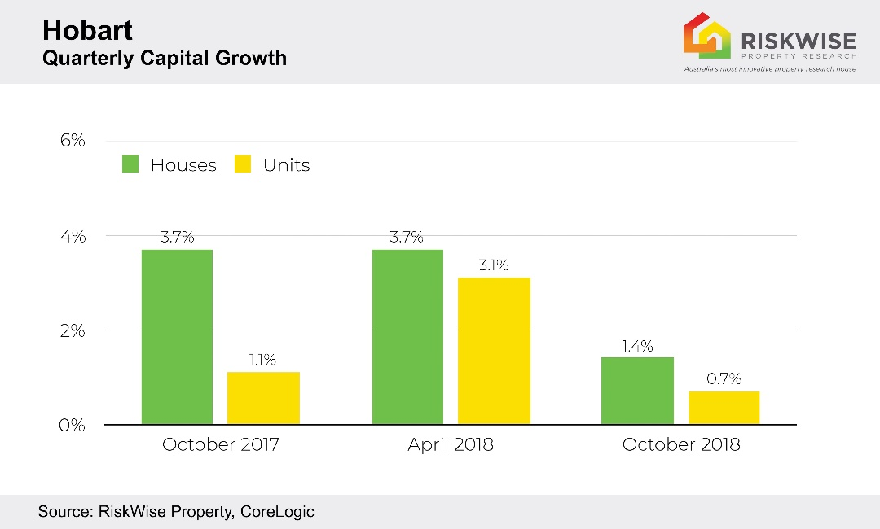

Mr Peleg said the relative economic growth in Tasmania was the second lowest in Australia. It also had the lowest median weekly wage and wage growth. The unemployment was the second highest in Australia and the annual median income of $57,200 per household, the lowest.

He said add to this higher credit restrictions and the fear of the potential impact of the changes to negative gearing and capital gains tax if Labor succeed at the forthcoming Federal election, it was possible price growth could decelerate further.

This is especially the case for units, which have a median price of $374,261, and obviously, off-the-plan units, which carry a higher level of risk in Hobart. Annual growth for units in Hobart is 9.8 per cent.

He said should the ALP policy, to limit negative gearing to new dwellings only and cut the capital gains tax in half, be implemented there would be reduced demand to purchase rental properties due to the creation of primary and secondary markets, and this would cause new dwelling prices to decline in many regions.

“The transfer of the property effectively changes its status from the primary to the secondary market, from a taxation perspective, however, the same taxation benefits from a property in the primary market would not be available to a subsequent investor,” he said.

“The new purchaser will not be able to claim negative gearing against their wages and the capital gains tax discount will halve. Therefore, the vendor must drop the value of the property because the benefits to the buyers are lower, and it is therefore not as attractive to potential buyers.

“In addition, the unit market is mainly driven by investors, of which intra-state buyers make up a relatively high proportion, and if there are better opportunities in other areas, there could be a huge shift, and this could have a significant impact on the market.”

In fact, he said, in terms of houses, at least, there were significantly superior investment alternatives, especially in regional Victoria, such as Geelong, and southeast Queensland, so there was a risk of a reduction in investor activity in Tasmania once the excitement cooled off.

The median price for a house in Hobart is $475,568 and in Geelong $591,640. The Victorian port city enjoyed three-month capital growth of 1.85 per cent and 12-month growth of 13.9 per cent.

Mr Peleg said the forecast for Geelong was extremely positive.

“High population growth and a rise in infrastructure projects has led to an improved economy and more jobs. Add to that it only takes an hour to drive to Melbourne and, by comparison, its housing is significantly more affordable, it is ticking plenty of boxes for a lot of people with their eye on capital growth in the future.

“And we believe it will only get more popular in the next few years, thereby presenting projected solid capital growth, especially when you consider that due to stricter lending conditions many owner-occupiers who now have lower borrowing capacity are still able to buy there and conveniently commute to work.”

Real Estate Institute of Tasmania president Tony Collidge said while their September quarterly report saw Hobart retreat in terms of median prices there would not be a dramatic fall because it was not a big market at just 11,500 sales a year.
“Which is so low when you think that amount of sales takes place in Sydney in about a month to a month-and-a-half and in Melbourne in about two months. Our market is structured very differently to bigger capital cities as it is 70 per cent owner-occupied and 30 per cent rental,” Mr Collidge said.
“We also have a buoyant economy thanks to tourism, infrastructure and general construction as well as tertiary education which is another booming product with rapid growth in enrolments so at the moment in terms of price people are saying enough, we are almost on a par with Brisbane and Adelaide.”
He said while prices had cooled and dipped slightly, and less people were attending open houses making agents work harder, he did not think further drops would be significant because that demand was there, and they were moving into their peak tourism season.
“I am hearing from inner-city agents that while stock is low, the degree of intensity has fallen, and potential buyers are a lot more guarded and taking things at their pace. The market isn’t forcing the pace.
“In Sydney about 60 per cent of sales are rental properties so if you cut out foreign buyers all of a sudden you have a surplus supply of stock and you have a glut which impact prices. But here they make up 1 per cent of sales as it is a locally driven market, so we are a bit protected or insulated from that.
“The big question is how long the government can keep the tourism in a good place as if it slows it will impact confidence and employment.
“Of course, with Sydney and Melbourne off the boil and Perth starting to reheat, there is more scope for investors to look elsewhere and that has affected Tasmania.”
He said the market, while falling, was still buoyant and lack of supply would keep prices up, unless a flood of properties came on the market, which was unlikely.
“Properties for sale are down 50 per cent from two years ago and we also have low rental vacancy rates due to it being the prime tourism season for the next six months. Rental vacancy rates are about 5 per cent, so we have a huge shortage on both sides
“Regardless, 2019 will probably be the best year for sales in 14 years and will be the highest in terms of value of sales, which I believe will break, or go close to, $4 billion.”
Mr Peleg concluded that the large value of expected sales in 2019 and the decelerating price growth, put the market to the test. He also added that the current capital growth was unsustainable.
Visit www.riskwiseproperty.com.au

ENDS

About RiskWise:
RiskWise Property Research was formed in 2016 with the goal of providing property risk advise and research services to help its clients make informed purchasing decisions.
Its goal is to provide private investors, home buyers, property professionals and institutional clients with detailed risk information to support smarter decision making. Its vision is to be a global leader in property risk rating and research helping its clients to achieve deeper risk insights so they can make smarter property investment decisions.
Visit www.riskwiseproperty.com.au

To organise an interview with RiskWise CEO Doron Peleg please contact:
Vanessa Jones
Media & Communications Manager, RiskWise Property Research
Australia’s most innovative property research house
0421 057 129 | Vanessa.Jones@riskwiseproperty.com.au |
www.riskwiseproperty.com.au | Queensland, Australia

