THE ROXY THEATRE PARRAMATTA
Concept DA before Land & Environment Court
Diagram 1: The Roxy’s original form when completed in 1930.

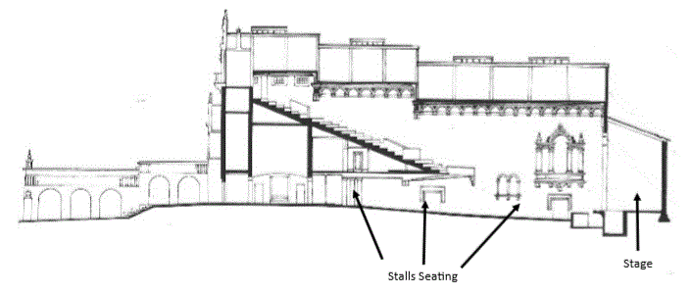

Diagram 2: All that will remain.
Lost area is shaded. Note complete removal of Stalls and stage areas.
Only Dress Circle remains.

