Media Release
31st July 2020
FOR IMMEDIATE RELEASE
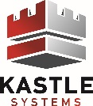
How Electronic Security Is Virus-Proofing The New Office
John Gellel

To protect employees at work, organisations are racing to figure out how to safely reopen workplaces. Employees are nervous in returning to work, they’re worried about a virus that can stay on surfaces for hours.
In comparison to other countries, Australia has managed the COVID-19 virus spread better than others.
Despite our success to date, according to health & political officials, we must not become complacent. The virus exists, it can spread rapidly, and the dynamics of our country can change overnight. The most recent example is by the Victorian Government, which placed greater Melbourne and the Mitchell Shire into a six-week lock-down and state governments closing their borders.
Many health agencies globally, including the World Health Organisation, are now suggesting a COVID-19 vaccine is ‘Years Away’. Even when a vaccine is ready, what is it to say Australia will receive the first batch of vaccines before other countries?
In the short term, Government can stimulate the economy through business and individual hand-outs, however, our economy cannot sustain this forever. Businesses need to be back in business and people need to be back at work.
How can we get people back to their workplace now? What technologies are available during this pandemic?
Video conference at home has supported our short-term needs. It’s a way for most workplaces to keep businesses moving, but it is a band-aid fix and working from home on an ongoing basis has its drawbacks. Those that are home video-conference regulars will know that our beloved NBN isn’t always perfect. Even if their NBN is high speed, that doesn’t mean others on the same calls are. Network instability and time lag is one common drawback to video conferencing. Outside of technical reasons, video conference makes away from personal contact (remember a large part of communication is from non-verbal actions), which then makes away with workplace collaboration.
Getting people back to the workplace requires a collaborative discussion with employers and employees. Whilst most will generally understand working from home cannot be forever, employees want their workplace to be a safe place. In a recent survey on the view of an employees safe return to work, there was some areas where the employee felt they won’t come back to work, if they were not addressed including:
- Employers ensuring there is a process to deny infected or symptomatic individuals
- Ensuring enough hand sanitisers are onsite
- Ability to check an employee or visitor’s temperature upon request
- Minimising the need to touch surfaces, from outside of the building to their desk
To get employees back in the workplace where an employee feels reasonably safe, employers are looking at ways to update their offices with a range of new technology & processes. Tenancies are also actively discussing what technologies & processes a post-COVID-19 building should be with their building managers.
Proactive building owners are implementing these new technologies & processes, not only to keep tenancies safe, but also as a way to market their building to prospective new tenancies.
So how will the office start to look like?
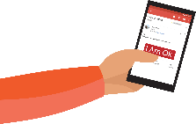
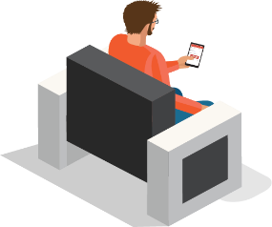
Before Leaving Home
One of the biggest challenges in getting people back to their workplace is the risk of COVID-19 spreading throughout their building. To minimise this risk, employees and visitors will be asked to ‘agree’ or ‘disagree’ with a series of questions relating to their health, confirming they do not have any COVID-19 symptoms. If the employee or visitor disagrees with the questionnaire, their access will be locked for the day, keeping them out of the workplace and minimising any potential virus spread.

The Building Lobby
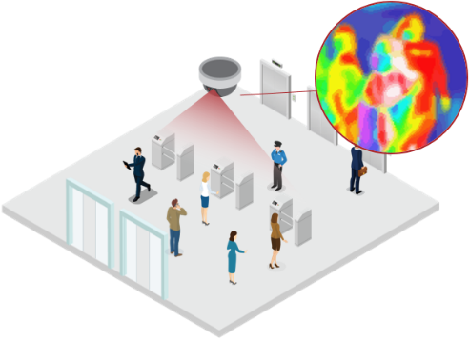
As workers return to the office, the lobby may resemble an airport security checkpoint. Those that confirmed in advance that they do not have any symptoms will be given fast lane access through security. As they pass through security, a thermal image camera will detect body temperature and will deny further access if the camera detects an elevated body temperature. Visitors will check in to the building via their phone. Once checked-in, they’ll also move through the security checkpoint and thermal camera, then be given access to the tenancies floor.

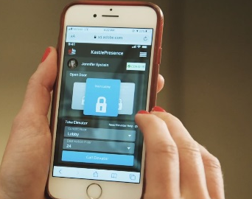
The Elevators
As coronavirus particles can remain on surfaces for hours or days, calling an elevator and selecting your floor, will all be done via an app. Quantity of people in each lift car will also be restricted to manage social distancing. When you’re ready to leave the office, you will call the lift and select ground, all via your app, instead of physical buttons in the lift lobby and lift car. A touchless lift experience.

The Tenancy
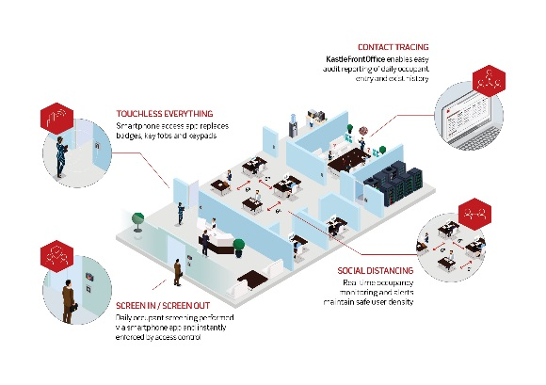
Once on the tenancy floor, a touch of your phone’s app will open the motorised door in the lift lobby to your tenancy. You may go through several other doors; all will be motorised and touchless. The touchless experience will continue through other services, such as lockers and bathrooms.
Social distance will be managed through floor markings and CCTV cameras will alert security if you’re in close proximity for more than a period of time. People counting through access control will ensure the maximum allowed people limit in the tenancy is not reached, based on the four-square metre rule. Once reached, employees and visitors will be denied access into the tenancy until someone leaves. This ensure compliance with mandatory health rules.
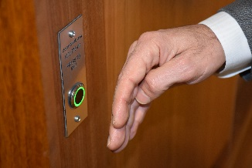
Everyone working 9am-5pm will be a thing of the past. Instead, to support social distancing, the office environment will be spread over multiple shifts throughout the day, with early starters and the second shift finishing later. Multiple shifts will be managed through the organisations access control, prevent building and office access outside of the employees shift.
At the time when an employee or visitor becomes COVID-19 positive, additional access control points and CCTV cameras will support the need for immediate contact tracing. Through technology, authorised staff will quickly assess when & where the employee (or visitor) was throughout the building, and who was in close proximity to the infected person.

While it may be difficult to see the end of this crisis today, all these technologies are available now and tenancy managers at all levels are discussing office and building upgrades with building owners for a safer return to work during these extraordinary challenging times.

###
About the Author: John Gellel is the General Manager for Kastle Systems Australia & Vice President for the Australian Security Industry Association Limited (ASIAL).
Kastle Systems is an integrated security service company, providing a safe return to the office workplace with KastleSafeSpaces, integrating technologies and processes to optimise access control with enhanced health safety protection. www.kastle.com
ASIAL is the national peak body for security organisations and professionals in Australia. ASIAL members account for approximately 85% of the Australian security industry. www.asial.com.au
Contact Details:
John Gellel
02 9428 7000
0438 800 032
jgellel@kastle.com.au

