Prestigious award winners at the 2019 National Conference
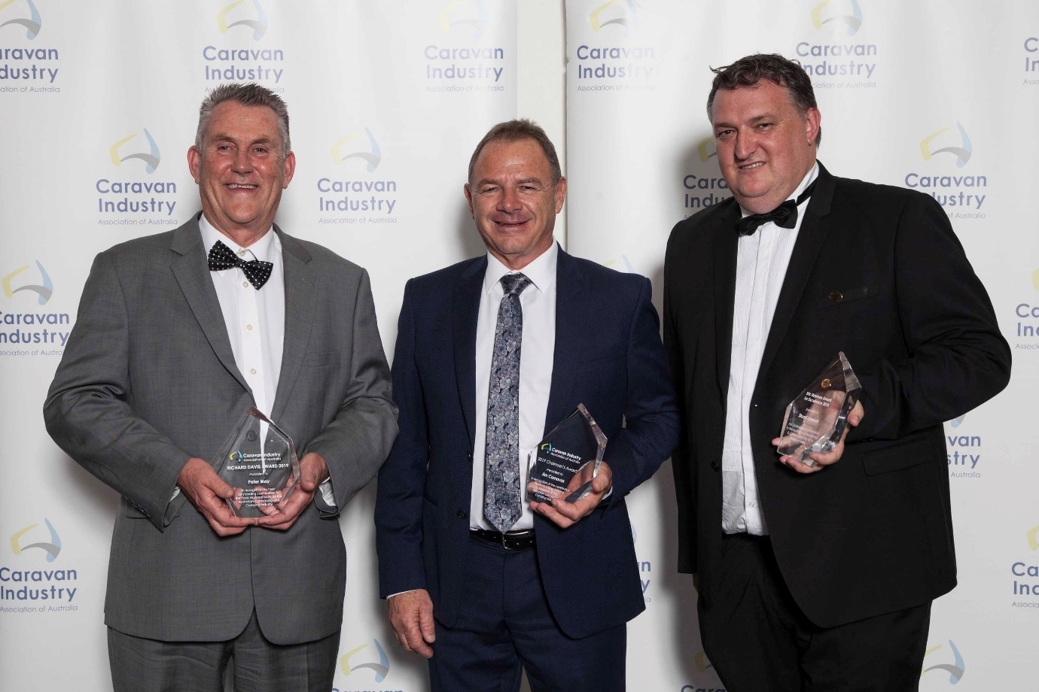

Eric Hayman Award:
Stuart Lamont
The Eric Hayman Award for Excellence is our industry’s most prestigious award, now in its 28th year. The award recognises extremely influential and hardworking industry leaders who have made a positive impact over the years.
This year, the recipient was Caravan Industry Association of Australia CEO Stuart Lamont.
Stuart has been instrumental in transforming two National Associations, RVMAA and CRVA, to form a single National Association, Caravan Industry Association of Australian and the introduction of an elected board.
As CEO he has been instrumental in a range of important industry activities including research and funding development, RVSA advocacy, implementation of a robust compliance program, growth of the Let’s Go Caravan and Camping marketing brand, the introduction of the Future Leaders Program and the incredible growth of the Caravan Industry National Conference.

The Richard Davis Award:
Peter May
The Richard Davis OAM Award for Outstanding Contribution to the Peak National Body was introduced in 2016 in dedication to the late Richard Davis OAM. This year it was awarded to Peter May.
As the then President of the Victorian Trade Association, in 2012 he raised the concept of the amalgamation of then CRVA and RVMAA at an industry forum and was ridiculed by some, but he was not deterred.
In October 2013 he met at the Middle Park Hotel in Melbourne with Mark Lindsay and Stuart Lamont to carve out what a new organisational structure could look like. The following month Peter represented the concept to the Industry Forum with greater acceptance and the start of the journey towards merger began.
He served on the Board of the then CRVA, and was a strong advocate for the appointment of an independent Board and the shrinking of the size of the Board.
Peter is a visionary and incredibly determined in persevering with his strong beliefs in the best interest of the industry.

caravancampingsales Future Leaders Award:
Amanda Baldwin
Amanda has held the position of Manager- Strategy and Acquisitions within the G’Day Group for nearly two years.
She has been an integral member of the group’s management team and has been leader in the acquisition of over 30 parks and provided critical strategy direction to the Board on major investment decisions.
In the last 18 months Amanda has been involved in pivotal G’Day Group investment decisions such as new glamping development on Rottnest Island and the annual strategy for the Group where pivotal technology investment decisions have been made.
Amanda is a chartered accountant and also holds a Graduate Diploma in Applied Finance (Business Valuation).

Gerry Ryan OAM Award for Innovation:
REDARC
This year, Caravan Industry Association of Australia was pleased to launch a new award carrying the name of Gerry Ryan OAM in recognition of his longstanding contribution to the industry and industry body.
The inaugural Gerry Ryan OAM Award for Innovation was presented to REDARC for their Redvision Total Vehicle Management System.
Redvision is a central control hub that connects electrical devices and displays vital information for a vehicle or RV on its on-board 12V accessories, setting a level of automation which brings information and control together in one place.
The judges commented that it has been designed and made in Australia, has been released to market rather than in concept and is used in 4WD, campers, and caravans.

Chairman’s Award:
Jim Carnavas
Each year we have the option of awarding or not awarding a Chairman’s Award for service to the industry. In 2019 the decision was made to recognise an outstanding contributor in Jim Carnavas.
In 1981, Jim and one of his fellow work mates purchased the Jayco / CUB dealership on the corner of Rode & Gympie Rd in Chermside.
He joined the board of Caravan Trade & Industries Association of Queensland in approximately 35 years ago, became President in 2001 and served for 18 terms until last year when he made the decision to step down. He is CTIAQ’s longest serving President.
Jim has been awarded Life Membership of CTIAQ, and in 2018 he was presented with the ‘Ron Chapman Award for Outstanding Contribution & Commitment by an individual’ to the Caravan Industry in Queensland.

