4 March 2019
Balance on wheels for a better life
International Women's Day is being celebrated on 8 March 2019. This year's theme, “Balance for Better,” aligns perfectly with CyclePower's passion of helping women of all ages and abilities find balance with their life. A balanced life goal is becoming increasingly more important for women’s personal health and well-being in a fast-paced, modern world.
CyclePower is an Australian company founded in 2012 to help riders become more active and support their healthy lifestyle goals.
The company is dedicated to supplying affordable electric tricycles that are easy-to-ride at any age.
“Some senior women are no longer able to drive or exercise the way they used to,” said Frank Riccobon, co-founder of CyclePower. “They're not ready to go to a motorised scooter, and they still want to get some exercise and fresh air. Our electric tricycle gives them a new lease on life as they experience the many benefits of riding an electric tricycle. It ticks all their boxes.”
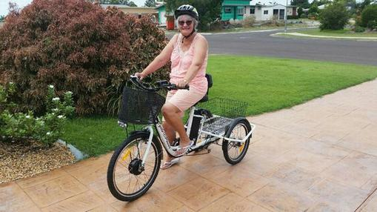
Beth arriving home after a ride
The CyclePower electric tricycle incorporates pedal assistance and motor input. While the rider is pedaling, motor input is activated. This helps the rider to experience less resistance while riding, even uphill. In pedal assist mode, the trike senses the amount of torque that is applied, and the motor automatically kicks on as needed, helping the rider endure hills and long rides.
CyclePower invites women to “ride where you please and enjoy the journey,” while improving circulation and overall health. With the unique leaning frame, in which the trike’s frame leans like a bicycle, the rear wheels remain stable giving riders more confidence. Balance is better achieved with three wheels.
Riders have enjoyed meeting and exceeding their life goals thanks to the company's electric tricycle. Jasmine Harvey went from using a wheelchair for three and a half years to riding a trike. Her testimony can be read on CyclePower's home page at https://www.cyclepower.com.au.
Netstar Media
Susan Riccobon
129-135 Bellbird Drive, Greenbank QLD 4124
0414071575

