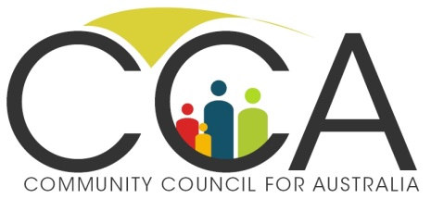
Media Release
27/3/20

The first ‘Charities Crisis Cabinet’ to meet on Tuesday

CCA is pleased to announce the establishment of the Charities Crisis Cabinet. The Cabinet will be seeking to enable as many charities as possible to survive through this pandemic and contribute to building flourishing communities after the crisis. It will draw on the broader charities sector to provide advice to governments, business, philanthropists and the community. The first meeting will be held on Tuesday.
Australian charities employ 1.3 million people, rely on over 3.5 million volunteers, and contribute 8% of Australia’s GDP. They are vital to our economy and our communities.
Cabinet Co-Chair Rev Tim Costello said today; ‘Many charities are facing a battle to survive. Fundraising activity is grinding to a halt. Activities that involve bringing people together have ceased. Volunteers and staff are much less available. Opportunity shops, churches, group training, fundraising events and socially based community activities are all shut down. Many charity workers have lost their jobs. As many as 300,000 could find themselves unemployed. These are tough times, but if we want Australia to have a vibrant future we need as many charities as possible to survive.’
Cabinet Co-Chair Susan Pascoe said, ‘I look forward to co-chairing this Cabinet. I hope that by coming together with leaders from across the charities sector, sharing our knowledge and experiences, we will be able to develop strategies to help more charities continue serving their communities.’
David Crosbie, Cabinet Secretary said; ‘The first Charities Crisis Cabinet meeting will be held on Tuesday. We want to hear from charities across Australia about what will assist them to remain operational. We know governments, business and communities want to keep supporting charities. We hope they will draw on the advice of this Cabinet in framing their responses to Covid-19.’
CCA has already written to the Prime Minister and the Treasurer calling for action to support charities including; locking in all existing government funding until 2021, allowing charities the flexibility to respond to their communities by not enforcing narrow contract and performance requirements, ensuring charities can access the same support packages as are being provided to small business, extending tax deductibility for donations to all charities, and increasing the tax offsets for donations for the next six months.
Membership of the Charities Crisis Cabinet is being finalised. Key leaders from the charities sector who have agreed to participate including CEOs from: ACOSS, Philanthropy Australia, Volunteering Australia, Smith Family, Save the Children, OzHarvest, Australian Major Performing Arts Group, Settlement Service International, World Wildlife Fund, Our Community, Pro Bono Australia, Centre for Social Impact, Life Without Barriers, Community Broadcasting Association of Australia, Australian Council for International Development, Justice Connect, etc.

Media Comment: David Crosbie 0419624420

NB. The term "cabinet" comes from the Italian word "cabinetto," meaning "a small, private room." A good place to discuss important business without being interrupted. (Oxford Dictionary)

NB. Tim Costello will be seeking feedback and discussing the challenges facing charities as part of ‘Australia at Home’ on Monday, 1.00pm-2.00pm AEDT, free to join: https://www.eventbrite.com.au/e/australia-at-home-lunchtime-briefing-tim-costello-ao-tickets-101251389632?aff=ebdssbonlinesearch

