MEDIA RELEASE
FOR IMMEDIATE RELEASE
For further details contact: Stieve De Lance 0431139681 sdelance@reputationaustralia.com.au
THE RISE OF THE ADULT CHILD WHO CAN’T OR WON’T LEAVE HOME
- Girls prove more independent
- The best and worst suburbs for kids failing to thrive financially (List)
- Men from areas of lower median house prices are worst affected and more likely to live at home
- The ability to leave home is related to the median house price but not as you might think
- Cheapest areas have the highest adults kids still at home
- The inability to leave home places their future wealth in jeopardy
- Parents are hiring financial coaches to get the kids out of home
Sydney July 12, 2017, The latest census reveals that more post-university aged adults (25-34 years) are living at home than ever before. This figure shows that despite having degrees and the ability to work in good jobs, they still can’t save and rely on mum and dad instead of learning how to manage money.

There are now 113,868 non-dependent children aged from 25 to 34 living at home compared with 110,238 just five years ago, of which 67738 are boys, and 46130 are girls. That is nearly the entire population of Newcastle living off Mum and Dad.
Housing affordability Expert and Financial Planner Robert Snell says that the lack of financial skills is preventing adult children from moving out and buying their properties and that this delay is a million dollar problem for each young adult.
“Young people today are not getting the financial coaching they need to live in today's world. Things are different for them than it was for their parents and you can't use the old ways of doing things and hope to get ahead. The battle is lost once you get married and have kids, if you don’t get started in this essential age bracket, then they are going to struggle to get ahead. It also is harder, according to the data for males to get a start on the property ladder.”
As to answer why girls seem to be more independent, he points to a Canstar Blue (Young women feel the most financial stress) study that shows young women worry more about money while men in their late 20s are the most likely to ‘live for today’ when it comes to their finances¹.
He says that to create financial independence you’ve got to not only get a roof over your head but also save assets to provide income when you stop work later in life. Robert‘s research shows the effect of delay caused by housing affordability will have a monstrous effect on the next generation’s quality of life.
ENDS
Place | Population | Males 25-34 years | Females 25 – 34 years | Total | House Value (median)
Greater Sydney * | 4,823,991 | 67,738 | 46,130 | 113,868
Electorate
Sydney (CED142) 41.3 sq Kms | 200,181 | 777 | 565 | 1,342 | $1,339,181
Grayndler (CED117) 27.1 sq Kms | 149,513 | 1,164 | 809 | 1,973 | $1,350,503
Parramatta (CED135) 56.5 sq Kms | 186,320 | 2,566 | 1,770 | 4,336 | $973,210
Mackellar (CED126) 212.5 sq Kms | 148,613 | 1,630 | 1,112 | 2,742 | $1,417,632
Watson (CED144) 47.7 sq Kms | 174,806 | 3,347 | 2,191 | 5,538 | $1,030,528
Bradfield (CED106) 98.4 sq Kms | 160,255 | 1,766 | 1,379 | 3,145 | $1,865,057
Reid (CED137) 48.9 sq Kms | 181,347 | 2,246 | 1,765 | 4,011 | $1,758,112
Mitchell (CED129) 98.4 sq Kms | 153,449 | 2,466 | 1,821 | 4,287 | $1,097,781
Barton (CED102) 39.6 sq Kms | 172,850 | 2,483 | 1,836 | 4,319 | $1,205,215
Kingsford Smith (CED122) 57.7 sq Kms | 176,238 | 1,876 | 1,341 | 3,217 | $1,668,283
Greenway (CED118) 80.5 sq Kms | 172,850 | 2,620 | 1,722 | 4,342 | $757,974
Chifley (CED108) 129.4 sq Kms | 171,249 | 3,320 | 2,133 | 5,453 | $587,306
Lindsay (CED123) 349.2 sq Kms | 166,528 | 2,331 | 1,475 | 3,806 | $597,723
McMahon (CED128) 163.2 sq Kms | 166,528 | 3,837 | 2,548 | 6,385 | $742,051
Fowler (CED115) 60.3 sq Kms | 164,235 | 4,131 | 2,642 | 6,773 | $768,297
Werriwa (CED146) 169.6 sq Kms | 170,909 | 3,871 | 2,531 | 6,402 | $690,989
Banks (CED101) 49.4 sq Kms | 155,806 | 2,646 | 1,906 | 4,552 | $1,033,044
Cook (CED109) 64.4 sq Kms | 139,062 | 1,741 | 1,350 | 3,091 | $1,033,044
Hughes (CED119) 323.7 sq Kms | 144,289 | 2,240 | 1,492 | 3,732 | $937,423
Bennelong (CED103) 58.6 sq Kms | 168,948 | 2251 | 1775 | 4026 | $1,500,834
North Sydney (CED132) 41.6 sq Kms | 161,526 | 1201 | 1035 | 2236 | $1,500,834
Warringah (CED143) 52.3 sq Kms | 147,333 | 1,144 | 864 | 2,008 | $1,900,864
Wentworth (CED145) 28.3 sq Kms | 145,949 | 840 | 712 | 1,552 | $2,472,431
Blaxland (CED105) 61.1 sq Kms | 174,634 | 3,418 | 2,207 | 5,625 | $851,266
Macarthur (CED125) 375.9 sq Kms | 162,017 | 2,890 | 1,761 | 4,651 | $544,683

*We note that the ABS definition of greater Sydney doesn’t perfectly align with the electorates identified.
Source: ABS Census Data 2016

EXAMPLE:
The median price in Sydney just ten years ago, being $521,500². Over ten years³ a couple then aged 25 might have had the chance to pay it off. So by the time they reach the current day (aged 35), they’ve now got the capacity to save for their retirement. Let’s say they save their home repayments of $4334 a month from this point, at retirement they will not only own their own home but also have an extra $3,172,856⁴ (returns at 4.5%) at the age of 65 thanks to these savings.
Let’s take a look at the cost of delay as at today, as the same couple that didn’t buy a house ten years ago. In 2017 the couple now aged 35 are faced with a median house price in Sydney is $1,151,565⁵. If they have a deposit saved, they might pay this off over 20 years⁶. This means they can start saving at the age of 55 for their retirement. Let’s say they also save the home repayments of $5834 per month from this point, at retirement they will not only own their own home but also have an extra $860,273⁷ (returns at 4.5%) at the age of 65.
So what is the cost of delay?
The couple has paid an extra $630,065 for dollars for their home. They’ve also lost $2,312,583 in savings that could have been used to fund their retirement. Of course, the true situation in this example is likely even worse, given the simple assumptions in the second example, like having saved the larger deposit.
So what’s the moral?
The cost of delay in this example is $2.3 million dollars.
The real moral of the story is:
1. Starting early makes the world of difference to the quality of your life and gives you more life choices.
2. We need to do something about housing affordability – it’s not just about supply.
3. Kids don’t always listen to their parents. But the parents need to get their kids started as soon as possible. The solution is provided by the Life Values Own It programme which helps young people buy and pay off their first home sooner with advice and coaching.
4. If you follow the smashed avocado debate, at $2 per avo, this would put 1,656,291 avocados for your retirement or 154,172 smashed avo brunches at $15 each. Both of these are more than you’ll ever be able to eat in retirement!
References
1. https://www.canstarblue.com.au/services/banking/young-women-financial-stress/
2. ABS Statistics – Median House Price
http://www.abs.gov.au/ausstats/abs@.nsf/Products/DA26A389A22C29F1CA2573A1007B4DFE?opendocument
3. Repayments $4334 per month, Money Smart Calculator Home Loan Calculator, ten year loan, 4.5% interest rate on loan.
4. Savings $4334 per month, Money Smart Compound Interest Calculator, 30 years.
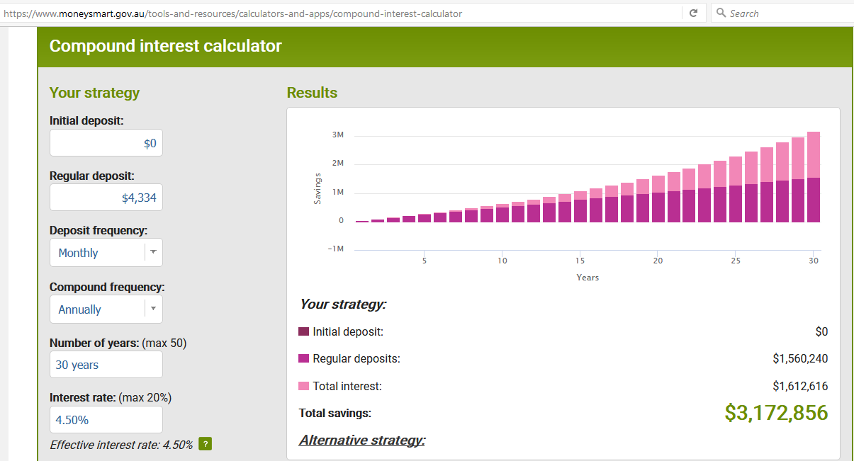
5. Domain – Median House Price
https://www.domain.com.au/news/sydney-median-house-price-hits-115-million-buying-becoming-out-of-the-question-20170419-gvmnp8/
6. Repayments $5834 per month, Money Smart Calculator Home Loan Calculator, 20 year loan, 4.5% interest rate on loan.
7. Savings $5834 per month, Money Smart Compound Interest Calculator, ten years.
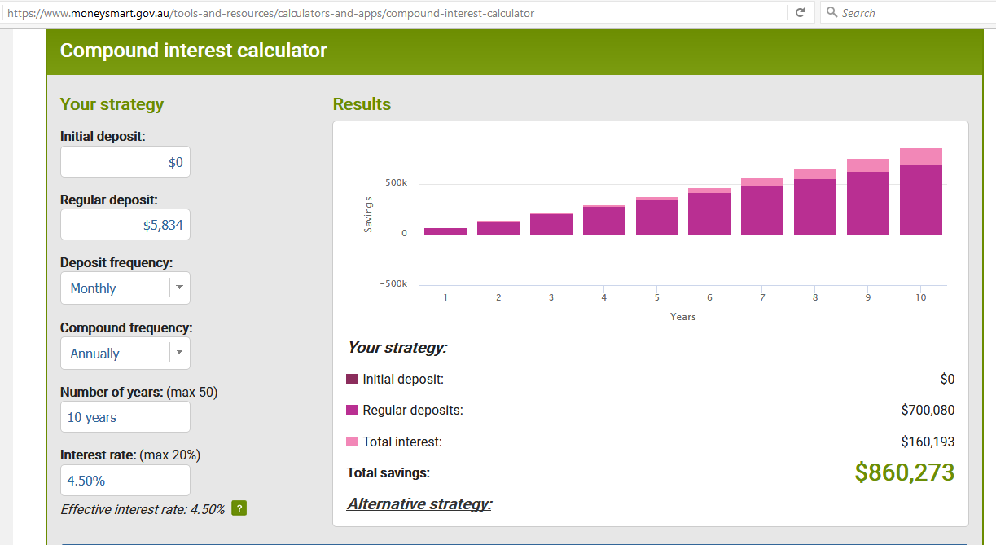
About Robert:
Housing Affordability Expert, Robert Snell has a personal challenge: To help 1000 young people buy and pay off their first home in 80-120 months He believes that if you work in a city, you should have a reasonable chance to buy a home in that city and that rising home prices are not a sign of success – being able to house your population is. He feels at some point, a home must just be a home and not an investment if Australia is to continue to house its growing population.
Robert has been a passionate advocate for first homebuyers for many years and has seen the challenges first hand with his client base. Parents of adult children and young adults themselves increasingly worry about how they will ever be able to afford to buy a home. He also worries how his son might ever afford to buy a home in Sydney. He has written and submitted a White Paper called, THE REAL HOME TRUTH: Why Unaffordable Housing for Young Australians Hurts Us All. It explains historically how we got to this situation in Australia and how we can turn things around.
Robert Snell is available to discuss:
· Tips on Saving
· How to get your first home
· What the country should do to solve this problem and its historical context
· Provide case studies
Robert holds a Degree with Majors in Economics and Political Science and a Diploma of Financial Planning. Robert is also recognised as an SMSF Specialist AdvisorTM and a Certified Financial Planner®. Unlike other advisors, Robert has been a fee-for-service advice provider for more than 29 years. Robert Snell is an Authorised Representative and Life Values is a Corporate Authorised Representative of Financial Services Partners Pty Ltd AFSL 237 590 ABN 15 089 512 587.
To read more about Robert, go to www.lifevalues.com.au

Tax Advice Warning
This information (including taxation) is general in nature and does not consider your individual circumstances or needs. Do not act until you seek professional advice and consider a Product Disclosure Statement.

