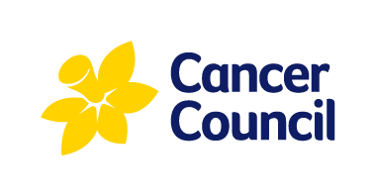
MEDIA RELEASE
3rd December 2019
Bowel cancer campaigns could save over 4300 Australian lives
Cancer Council Australia calls for extended Government investment to continue to increase screening program participation
New research released today has highlighted the lifesaving potential of promoting bowel cancer screening, showing that a national four-year awareness campaign could prompt over one million Australians to participate in the screening program and save 4,330 Australian lives over the next 40 years.
The modelling, conducted by Cancer Council NSW and published in the journal Public Health, also shows that a four-year national campaign could prevent 8,100 bowel cancer cases.
The release of the new research coincides with data released by the Australian Institute of Health and Welfare on Monday showing that only 42 per cent of eligible Australians took part in the National Bowel Cancer Screening Program in 2017/18.
Anita Dessaix, Chair, Public Health Committee, Cancer Council Australia said that the Federal Government should be applauded for funding Australia’s first national mass media campaign to promote the bowel cancer screening program in 2019 but stressed that continued investment was crucial.
“In 2019 Minister Hunt awarded Cancer Council a $10 million grant to deliver Australia’s first national bowel screening mass media campaign – analysis of the results is currently underway but early indications suggest a promising increase in screening uptake.”
“This first campaign was a fantastic landmark investment from the Government and we know from other state-based campaigns that we can normalise bowel cancer screening through Government-funded advertising. By extending the current campaign by another three years would save even more lives and prevent even more cancer cases.
“There is a clear case for continued Government investment, with this investment also being highly cost effective, costing Government an estimated AUD $2,500 per life year saved.”
Ms Dessaix said that it was encouraging that the latest AIHW data showed a small increase in the number of Australians taking the bowel cancer screening test – and encouraged more eligible people to do the same.
“The message to the Australian public is simple – if you are aged 50 – 74 do the free test when it’s sent to you in the mail. It could save your life. We need to lift participation rates well beyond the current rate of 42 per cent.”
Ms Dessaix also said that the data released today showcases where the biggest opportunities for increasing screening participation lie, with screening rates continuing to be lower in men and those aged 50-54, the youngest age group to be sent the free screening test.
The Australian-government's National Bowel Cancer Screening Program sends free screening kits to the homes of people aged 50 – 74 every two years. Bowel cancer is Australia’s second biggest cancer killer, but over 90 percent of cases can be successfully treated, if found early.
ENDS
For media enquiries or interviews contact Hollie Harwood on (02) 8063 4109 or email media@cancer.org.au

