Brand new awards presented at 2019 National Conference
At the 2019 National Conference, Caravan Industry Association of Australia presented two new people’s choice awards to both caravan parks and dealers.
These new awards are in recognition of strong customer loyalty, business performance and organisational discipline that deliveries experiences and propositions that are worthy of recommendation.

ReviewPro People’s Choice Caravan Park Award
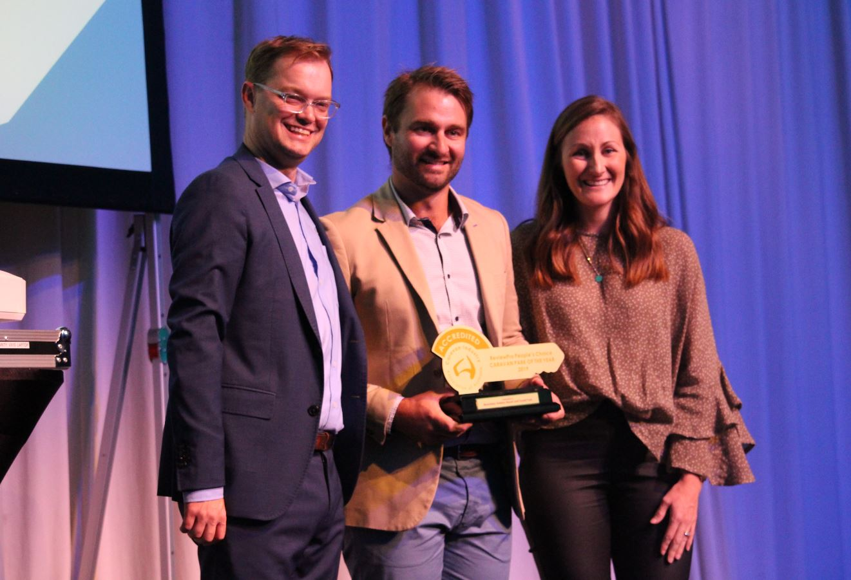

Maintaining outstanding online reputation is testament to those caravan park operators that deliver great visitor experiences, exceptional customer service and constantly exceeding their guest’s expectations. At this year’s national conference, we are proud to introduce our new ReviewPro People’s Choice Caravan Park Award to recognise those businesses for their outstanding effort. Through our partnership with ReviewPro, this award is 100% based on the online reviews and customer feedback of all our accredited caravan parks.
- Bronze: BIG4 Atherton Woodlands Tourist Park
- Silver: Caloundra Waterfront Holiday Park
- Gold: Mandalay Holiday Resort and Tourist Park

RVMAP People’s Choice Award Manufacturer of the Year
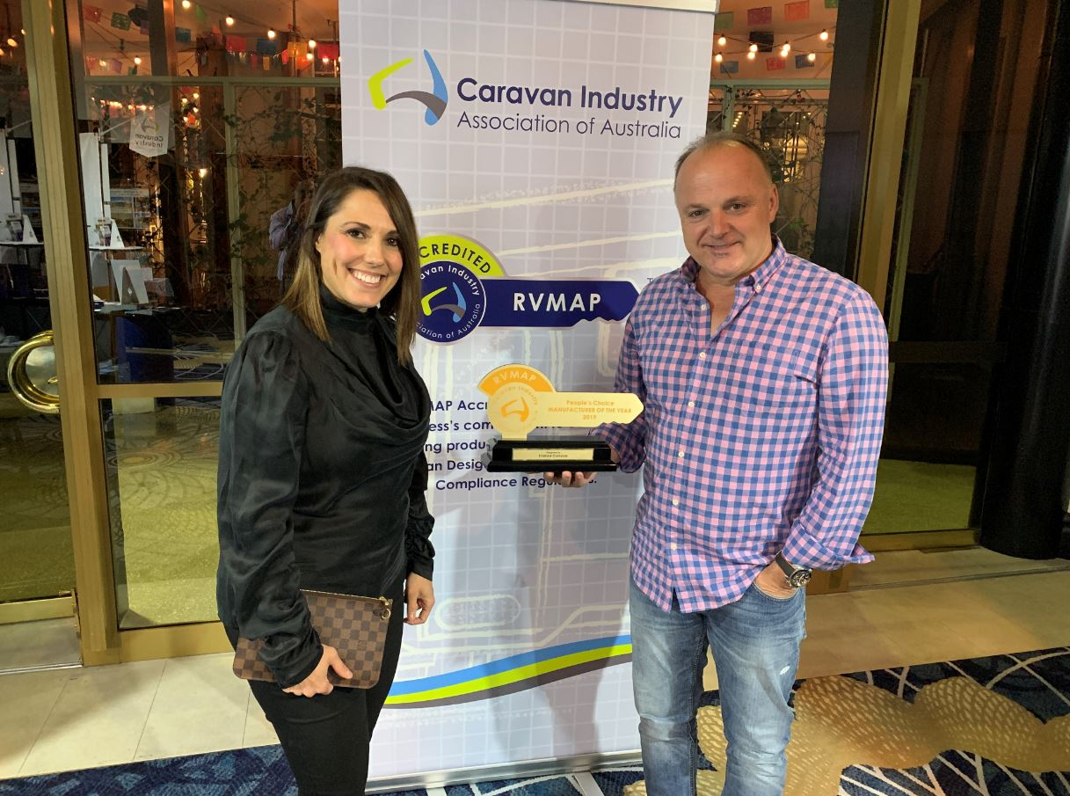
Obtaining strong customer loyalty is a testament to a business’s performance and organisational discipline that delivers experiences and propositions that are worthy of recommendation. The new RVMAP People’s Choice RV Manufacturer Award recognises those businesses that have excelled in meeting their customer’s needs throughout the product delivery and the purchasing journey. This award is 100% based on customer feedback from over 1000 consumers across all RVMAP manufacturing businesses.
- Bronze: Traveller Caravans
- Silver: JB Caravans
- Gold: Evernew Caravans

