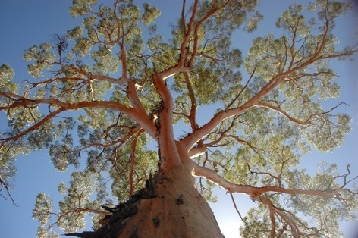
Ghost gums and bloodwoods and mallees, oh my! Who will win Eucalypt of the Year?
Monday 18 March
Eucalypts have been around for more than 50 million years, make up some of the tallest flowering plants in the world, and can even suck gold up from the ground! With around 900 species living today, eucalypts form an iconic part of the native Australian landscape.
Each year on National Eucalypt Day (23 March), Eucalypt Australia announces the Eucalypt of the Year, as decided by the public. Last year the river red gum, Eucalyptus camaldulensis, took out the big prize, but who will win this year? The votes are already coming in and the competition is running hot.
Salmon gum (Eucalyptus salmonophloia). Credit: Suzanne Prober
As Australia grapples with the impacts of a warming climate, there has never been a more important time to bring attention to our eucalypts as a critically important and unique native flora.
Voting closes 5pm on Friday 22 March, and the winner will be announced on Saturday 23 March.

How to vote for your favourite eucalypt
Submit your vote via this online form, or tweet your vote @EucalyptAus using the hashtag #EucalyptoftheYear.

Fast facts about eucalypts
- Eucalypts can be divided into three groups: Corymbia (bloodwoods), Angophora (apples) and Eucalyptus – the group that forms the bulk of the species.
- Their leaves and bark shed easily and are highly flammable, but it’s all part of their survival strategy: a fire that burns hot and moves through a eucalypt forest quickly won’t do as much damage to the trees as a fire that burns slowly.
- They can sequester gold: eucalypts in the Kimberley that were sitting on top of underground gold deposits were found to have tiny particles of gold in their leaves and bark, which they sucked up from the ground.
- Koalas don’t really get drunk from eating eucalypt leaves: eucalypt leaves are low in energy, so koalas must eat up to a kilogram each day to meet their energy needs. To conserve this energy, koalas sleep around 22 hours per day – a behaviour which has led to this common misconception.
Talk to the experts
Professor Belinda Medlyn (Sydney)
Belinda is a professor of ecosystem modelling at the Hawkesbury Institute for the Environment, Western Sydney University. Her research aims to predict how Australian forests will respond to changing climate and climate extremes.
“I love Angophora costata – the Sydney red gum – for its striking smooth red bark, which is always cool to the touch. They grow in most of my favourite parks around Sydney, so I can be sure to find one when I go for a walk and it’s always like seeing an old friend.”

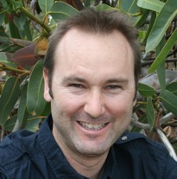
Dr Dean Nicolle (Adelaide)
Dean is an arborist, botanist and ecologist, specialising in the eucalypts. He established and maintains Currency Creek Arboretum in South Australia, a world-renowned eucalypt research arboretum with over 800 species of eucalypts.
“I’m nominating the smallest-growing species of them all, Eucalyptus vernicosa (varnished mallee). This unusual species is endemic to alpine habitats on high, windswept ridges in the western half of Tasmania, where it usually grows as a ground-hugging shrub. Ironically, is rarely grown in Australia, but is grown as an ornamental pot plant in parts of Europe.”
Dr Suzanne Prober (Perth)
Suzanne is a Senior Principal Research Scientist with CSIRO Land and Water in Perth. Her research is centred on managing and restoring the natural diversity, ecosystem function, and resilience of vegetation communities, with particular interest in temperate eucalypt woodlands.
“One of my favourite eucalypts is the majestic salmon gum, Eucalyptus salmonophloia. Salmon gums are the ‘living gold’ of the Western Australian goldfields – creating extraordinary orange and gold woodland landscapes against the red earth and blue skies.”

Professor David Watson (Albury-Wodonga)
David is an ecologist at the Institute of Land, Water and Society at Charles Sturt University in Albury/Wodonga. His research focuses on managing biodiversity in agricultural landscapes, measuring and predicting the biological effects of habitat fragmentation, and the ecology of parasitic plants like mistletoe, which often grows on eucalypts.
“I have many favourite eucalypts, both species and individual trees. But river red gums are hard to go past – to me they are the quintessential gum tree. I see them most days, and am the richer for it.”

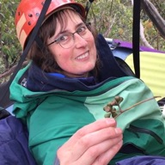
Dr Sue Baker (Hobart)
Sue is a forest ecologist and conservation biologist with the University of Tasmania. She works in Tasmania's beautiful tall eucalypt forests, researching how different types of plants and animals respond to forest management and fire.
“My favourite eucalypt is Eucalyptus regnans – Tasmanian's call it 'swamp gum', but I prefer the Victorian name 'mountain ash'. To me, they are the most magnificent of trees: tall and strong with a rough bark base and beautiful smooth bark for most of the trunk and branches.”

Associate Professor Peter Vesk (Melbourne)
Peter is a quantitative ecologist at the University of Melbourne, bridging the gaps between field ecology of plants, comparative ecology, modelling and conservation decisions. He is particularly passionate about how eucalypts are distributed along gradients in the environment.
“One of my favourites is the blackbutt, Eucalyptus pilularis, a tall forest tree of the temperate and subtropical east coast. Big boughs, lofty height. Forever in my mind as the snake tree on my parent’s bush block.”

For interviews and more information, please contact:
Ellie Michaelides, Remember The Wild: Ellie.michaelides@rememberthewild.org.au, 0404 809 789
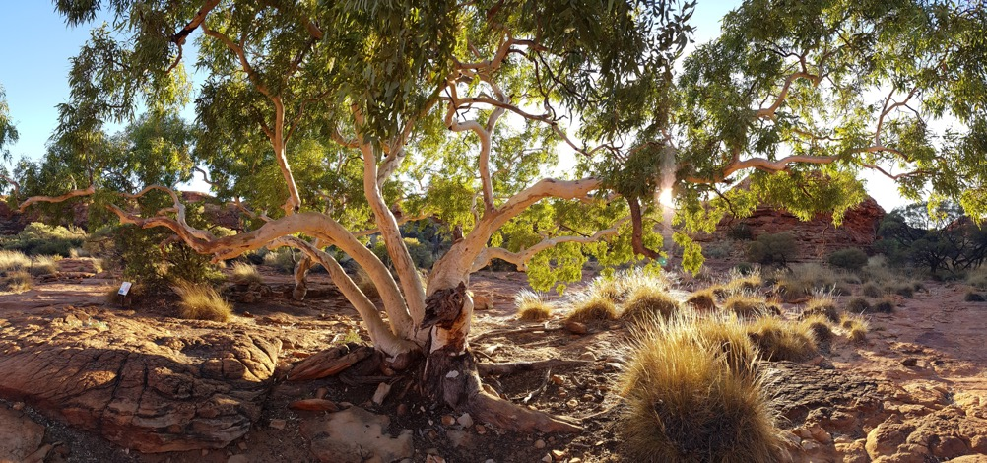
Majestic spreading eucalypt, Kings Canyon, NT. Credit: Cathy Cavallo

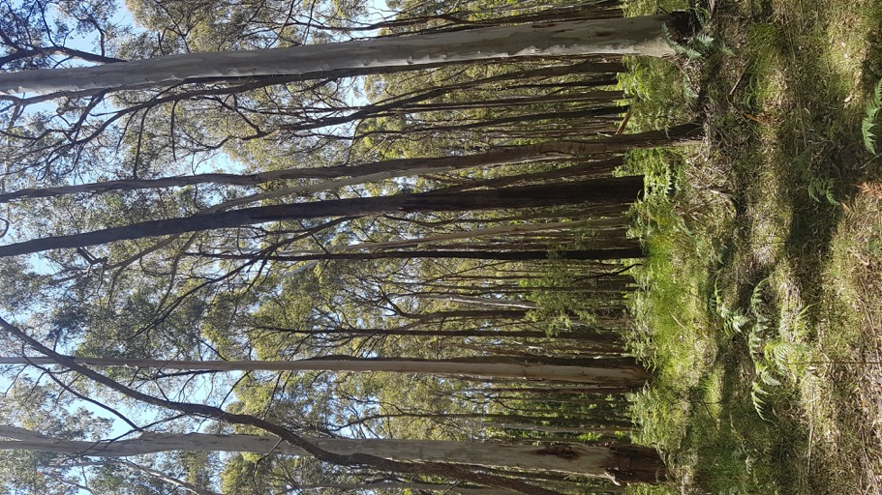
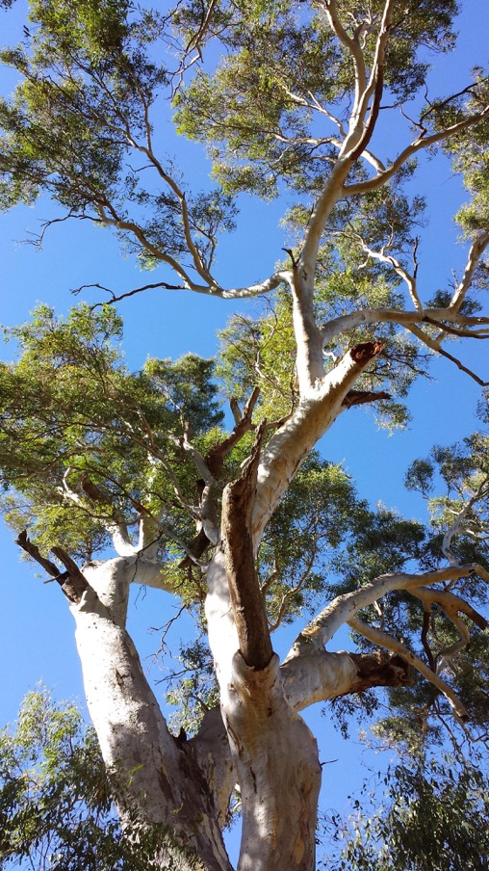
Mixed eucalypt forest, Trentham, Victoria. Credit: Cathy Cavallo
Ancient river red gum, Barmah National Park, NSW. Credit: Cathy Cavallo

