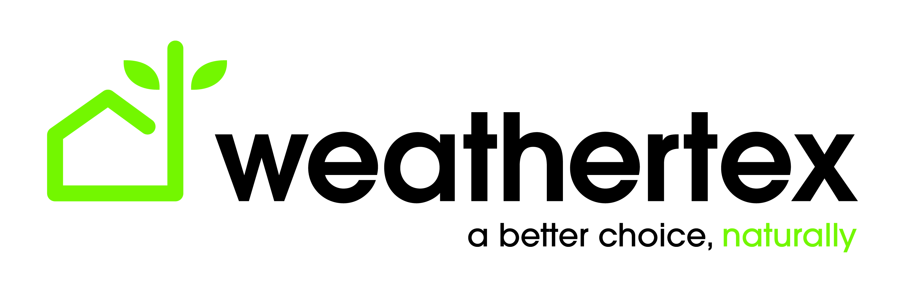
FOR IMMEDIATE RELEASE: 06.08.19

GET THE FACTS about the proposed NCC changes and how Weathertex products remain the industry leader in timber cladding

6th August 2019
Weathertex’s industry-leading timber cladding products continue to comply with Australia’s stringent building codes and remain a high-quality choice for specifiers, builders and property owners.

- Weathertex remains the industry leader in external timber cladding.
- Weathertex timber cladding can still be used on ALL Class 1 and other low rise building classes. (refer to attached for information on all building classes)

Named the Number 1 Trusted Brand in 2016 and 2018 by Architecture and Design, Weathertex is dedicated to ensuring its Australian-made products meet and exceed every standard of durability, sustainability and safety. Weathertex products are 100% natural and use NO silica, glues, resins or formaldehydes.

The Australian Building Codes Board (ABCB) has proposed changes to its National Construction Code (NCC). These changes have affected the use and applications of timber cladding products in some circumstances. Weathertex products stand in compliance with this code, are safe and fully usable in a vast number of builds.

This building code amendment, which is scheduled to come into effect in 2020, will only affect 3 and 4 storey Class’s 2 and 3 buildings.

Timber cladding can still be used on ALL Class 1 (houses, townhouses and apartments) and other low rise building classes.

At this point, the NCC has not changed. Standing concessions still apply to current builds that have been approved. No retrospective issues will arise with buildings already approved, and no product will need to be removed.

The company’s products are in strong demand across the building sector and continue to lead the industry in quality, sustainability and safety.

About Weathertex:

Australian owned and manufactured with a better than zero carbon footprint, Weathertex‘s timber cladding is the ideal solution for any builder, architect or designer in search for environmentally conscious and high quality material. All Weathertex products are made in Australia from PEFC certified state forest or private hardwoods without any silica, glues, resins or formaldehydes. Weathertex Weatherboards are guaranteed not to rot, split or crack for 25 years.
Weathertex ticks all the boxes. Australian owned with a better than zero carbon foot print, third party certifications, sustainable and in touch with today’s industry standards for a cleaner environment.

Visit https://www.weathertex.com.au/ for more information.

Media enquiries:

Vanda Correia
National Marketing Manager
vcorreia@weathertex.com.au

