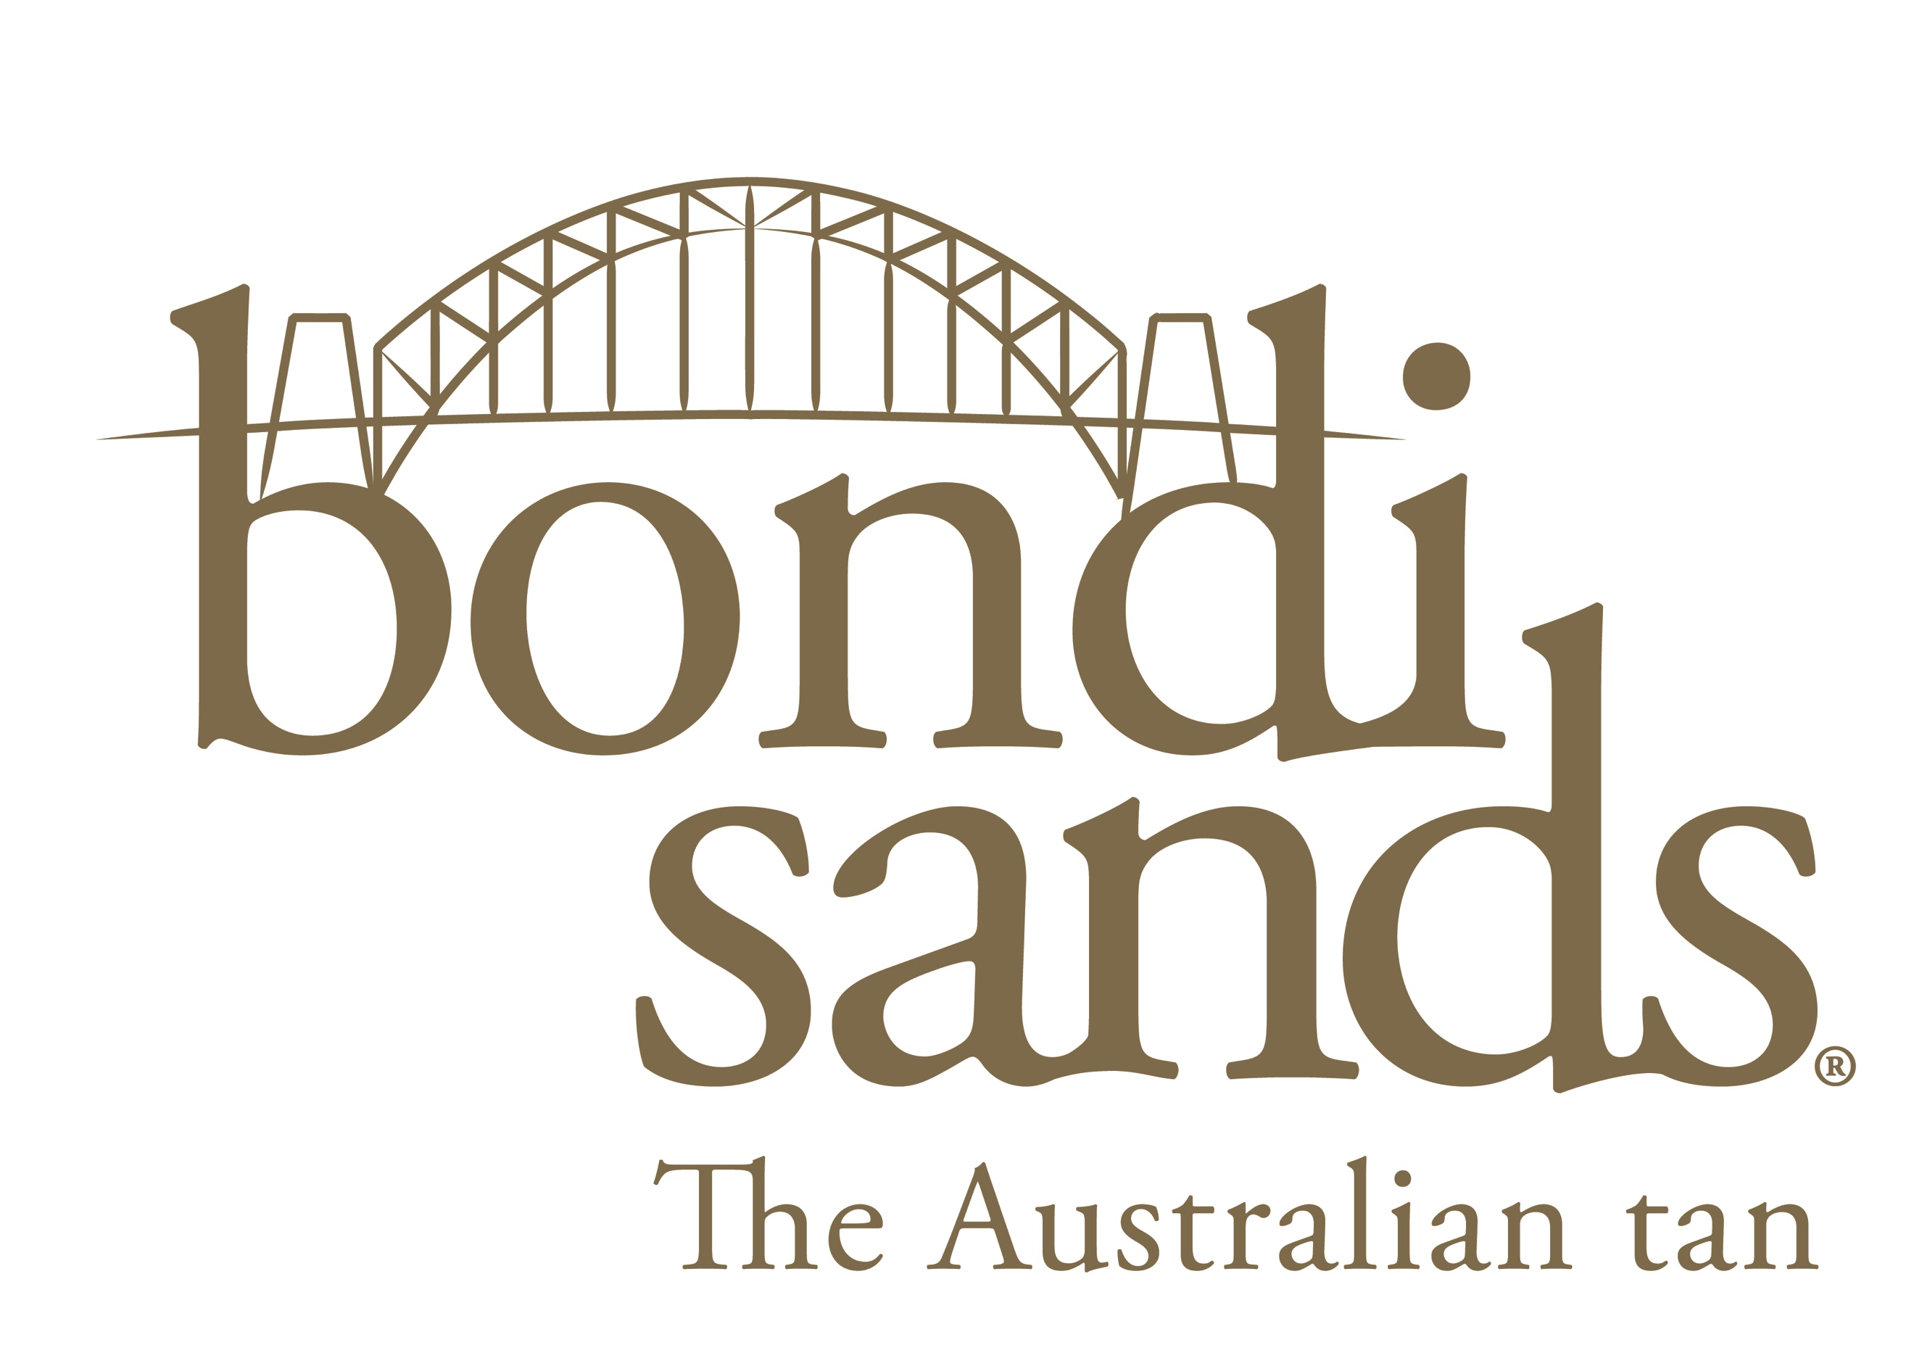

MEDIA ALERT

BONDI SANDS TAN SECURE WALGREENS IN LARGE USA ENTRY DEAL

November 2018: Australian self-tanning brand Bondi Sands are today celebrating the unprecedented launch into the USA giant retailer Walgreens. In one of the largest launches for an Australian beauty brand in USA history, this partnership with Walgreens will see Bondi Sands announced as “Category Captain” into 7,000 of its stores nation-wide.
Bondi Sands objective as Category Captain is to ensure Walgreens is the number 1 Self-Tanning destination in the USA, a first for an Australian brand in Walgreens. Bondi Sands has been given the responsibility to design and update the current Self-Tan point of sale touch points in store across all Walgreens stores with the focus on creating an educational in store experience for the American consumer.

Bondi Sands will be on Walgreens shelves by January 2019.

“We are extremely excited by our partnership with one of the leading retailers in the world, Walgreens. We have enjoyed a successful relationship with their co company Boots in the UK and are equally excited by positioning Walgreens as the ‘go to' self-tanning retailer in the United States. Our team have worked tirelessly over the last 18 months in preparation for our entry into the USA market and it is not only a proud moment for us but for Australian manufacturers and brand owners alike” Shaun Wilson Co- Founder Bondi Sands

“Since launching Bondi Sands in 2012 we have set ourselves the goal of becoming the number 1 self-tanning brand in the world and this opportunity with Walgreens will give the brand a truly national foot print across the USA and will make our goal a reality within the next 12 months. This significant commitment from Walgreens is a testament to the work our team has produced and the support our global partners has given us throughout the life of our brand.”

Blair James – Co-Founder Bondi Sands

Bondi Sands, the number 1 self-tanning brand in Australia, UK and New Zealand was launched in 2012 by business partners Shaun Wilson and Blair James. It is currently the market leader with over 60% market share in the three big Australian major retailers: Priceline, Coles and Woolworths and now with Walgreens the brand will have close to 18,000 retail partners around the world.

Bondi Sands will now be one of the largest beauty brand exporters of Australian owned and manufactured products, selling close to 10 million units this financial year which also includes suncare and cosmetic products.

The brand will enter stores with 10 of their global best-selling products; Dark Foam, Light Medium Foam, Express Foam, Tan Eraser, Liquid Gold, Gradual Tanning Milk, Dark Mist, the iconic Tanning Mitt and a selection of new products to also launch in 2019.

For further information and contact with the Bondi Sands brand owners please contact Portobello PR

MEDIA CONTACT:

CHARLIE BOYCE AT PORTOBELLO PR

EMAIL: CHARLIE@PORTOBELLOPR.COM.AU

TEL: 02 9360 5619

BONDI SANDS

- 80% of their online sales come from the USA. The brand is aiming to be the number 1 self-tanning brand in the USA within 2 years.
- The recently launched Express Foam has sold over 100K units in the first 4 weeks of launch and is the number 1 self-tanning product in the world (outside of USA)
- In the UK the brand has over 35% market share in both Boots & Superdrug UK (self-tanning) and over 65% market share in NZ (self-tanning)
- They currently sell 1 dark foam product ( their hero product) every 20 seconds globally
- Bondi Sands launched 5 world first products (Liquid gold, Men’s self-tan, Express foam, Protect and Tan and have a global patent on Tan Eraser which has sold over 800K units within the first year of launch. They are launching a further 5 world first products over the next 12 months (and a total of 15 more products across the range)

