Contact: Dr. Alistair Graham FOR IMMEDIATE RELEASE
Tel: (02) 9997 1100

Email: info@monavaledental.com.au

Mona Vale Dental Lead Dentist Reveals Painful Truth About Popular DIY Teeth Whitening Kits in an Exclusive Studio 10 Interview

Mona Vale, New South Wales, Australia – 19th August 2019 – As DIY tooth whitening kits continue to take over social media, Dr. Alistair Graham, principal dental surgeon at Mona Vale Dental, has revealed the full truth about home teeth whitening kits in a panel interview with Sarah Harris, which aired on 7 August 2019 on Network 10’s morning talk show, Studio 10.
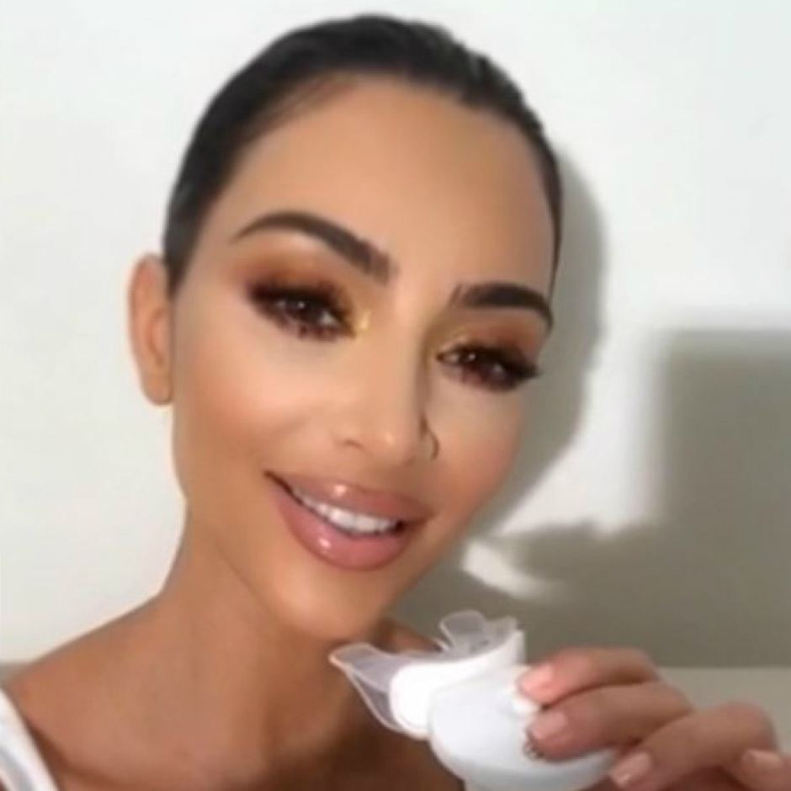
Figure 1: Instagram: HiSmile Teeth
A Bright Smile: Kim Kardashian is one of a number of celebrities promoting DIY teeth-whitening products to their social media followers.

Tooth whitening is one of the most popular cosmetic dental treatments in Australia today. Although people’s teeth naturally vary in colour, millions dream of having a brilliant white smile – however, the rise of DIY tooth whitening kits has sparked concern in the dental community leading to warnings that users may get more than they bargained for.

“Teeth whitening kits have sprung up just about everywhere on social media these days, promising people a dazzling white smile the easy way – and often, these are promoted by world-famous influencers who hold a lot of sway over their followers,” said Dr. Graham.

“However, that’s not to say that these kits are effective or even harmless. Use of these kits unsupervised can cause a range of dental issues, including gum irritation, ulcers, blisters, and even chemical burns.”

In the past few years, teeth whiteners have become increasingly popular with young adults in Australia as global celebrities including Kim Kardashian, Zlatan Ibrahimović, and Conor McGregor have promoted teeth whitening kits to millions of followers on social media.

In May, a report from the Australian Dental Association (ADA) revealed that 50% of consumers were using DIY teeth whitening kits rather than seeking professional services, with many using the kits for longer than recommended – despite the dangers. The ADA also found that some of the claims made by home teeth whitening kits exaggerated their product’s efficiency.

The report also noted that some overseas shippers sold products which contained whitening agents exceeding the legal limit, as well as making false ‘all-natural’ claims when their product contain abrasive chemicals such as sodium chlorite.

Under the Dental Board of Australia’s regulations, stronger teeth whitening products – those with more than 6% hydrogen peroxide or 18% carbamide peroxide – can only be used during in-chair procedures.

“In Australia, teeth whitening at a dental practice is regulated by Australian law and the regulations set out by the Dental Board of Australia,” added Dr. Graham. “Dentists don’t just offer safe procedures with professional results but can also offer guidance and advice for alternatives.”

For more information about teeth whitening or other dental procedures available at Mona Vale Dental, please visit monavaledental.com.au. For all general and media inquiries, please contact Dr. Alistair Graham at (02) 9997 1100 or info@monavaledental.com.au. The interview on Studio 10 can be viewed below.

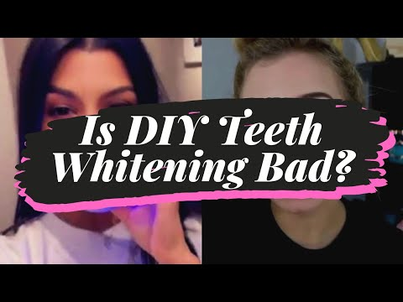

About Mona Vale Dental
Mona Vale Dental is a friendly, professional, and supportive practice that offers families the highest level of evidence-based dental care through comprehensive, modern treatment options. The practice works closely with its patients to ensure lifelong dental health through appropriate treatment. For more information about Mona Vale Dental, please visit the practice’s website.

Website: https://www.monavaledental.com.au/
Facebook: https://facebook.com/MonaValeDental/
Network Ten: https://10play.com.au/studio-10/lifestyle/2019/teeth-whitening-and-decay-causing-dental-disasters/tpv190807aytvz
ABC News: https://www.abc.net.au/news/2019-08-05/dentists-warn-of-dangers-of-diy-teeth-whitening/11381948
Australian Dental Association: https://www.ada.org.au/News-Media/News-and-Release/Latest-News/Teeth-whitening-Surging-popularity-brings-issues-t
Dental Board of Australia: https://www.dentalboard.gov.au/codes-guidelines/faq/use-of-teeth-whitening-products.aspx

Mona Vale Dental
1st Floor
8 -10 Waratah Street
Mona Vale NSW 2103
Australia

###

