June 2, 2019
Six key lessons from the recent property downturn

As the property downturn draws to an end, there are important lessons for policy-makers, lenders and investors to be learned.

Labor’s loss has eliminated the number one risk to the property market and this, combined with the high likelihood of interest rate cuts by the RBA this year, the introduction of the First Home Loan Deposit Scheme and APRA’s proposal to remove the 7 per cent ‘stress test’ replacing it with a 2.5 per cent buffer, will support the bottoming of the Sydney and Melbourne markets by the end of the year and then a gradual recovery.

RiskWise Property Research has identified six key lessons to be learned from the downturn and how to mitigate them to avoid another property crash in the future.

- RiskWise CEO Doron Peleg said despite claims by some experts it had been on the verge of collapse, the market remained viable, despite price falls. And, with a “good arsenal of tools” by the policy-makers, there should be no crash.

“In September last year, some experts warned of collapse due to ballooning household debt, compounded by sliding prices in Sydney and Melbourne, that would escalate to falls of 40 to 45 per cent in the next 12 months,” Mr Peleg said.

“Not only has it not happened - and would not even if the Labor had won the election - but more importantly, policy-makers have taken measures to boost demand.

“The First Home Buyers Scheme (that could also be a larger-scale first home buyers’ grant, if needed) was introduced prior to the election by the Coalition and was adopted a few hours later by Labor. In addition, the flow-on effect of lower property prices on household wealth, consumer spending and also on dwelling commencements and, consequently, lower GDP, increases the likelihood of interest rate cuts to ‘almost certain’.”

He also said APRA’s credit restrictions to reduce investor demand had eased and it was proposing lenders scrap the 7 per cent ‘stress test’ requirement on home loans replacing it with a buffer of 2.5 per cent on top of the interest rates.

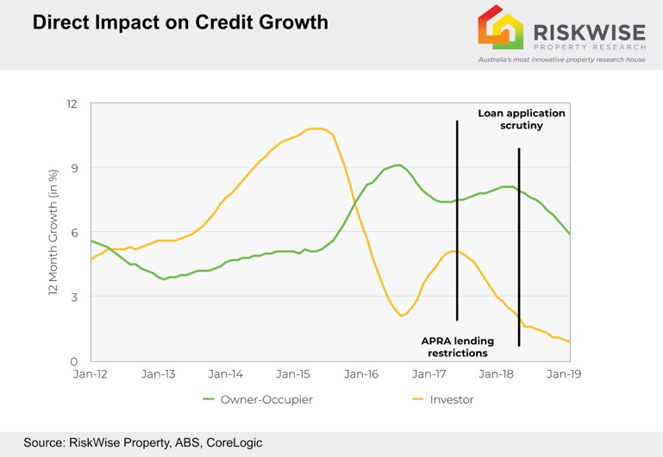

“The important thing to remember here is that in the future don’t expect total collapse of the housing market in a US GFC-style meltdown. It is extremely unlikely, and policy-makers take actions when required,” he said.

“It’s equally important that decisions should not be made under the assumption that very extreme scenarios will take place, for example, following the 60 Minutes story in September 2018 in which it was reported there could be a 40 per cent drop in Australia's house prices … this had an impact on sentiment and confidence to some extent.”

- A more aggressive monetary policy is required by the RBA.

“The RBA should have cut interest rates already and should not have made statements declaring the next move being upwards when there were so many economic indicators and key risk indicators that should have been taken note of, such as the strong connection between dwelling prices, household wealth and spending,” he said.

“An example of this is the stronger than expected fall in dwelling commencements, as published by RiskWise in December 2018, alongside an extended period of time when inflation was consistency well below target and wage growth was poor.”

- Investors amplify credit and dwelling price cycles contributing to financial stability risks.

“Therefore, any major reduction in investor activity has an impact on the demand of both existing and new properties,” Mr Peleg said.

“It is unrealistic to expect an increase in dwelling commencements when investor activity is significantly reduced. This is a key lesson for any policy-maker who proposes a policy with a major impact on investor demand, and the proposed taxation changes by Labor are a prime example for that.”

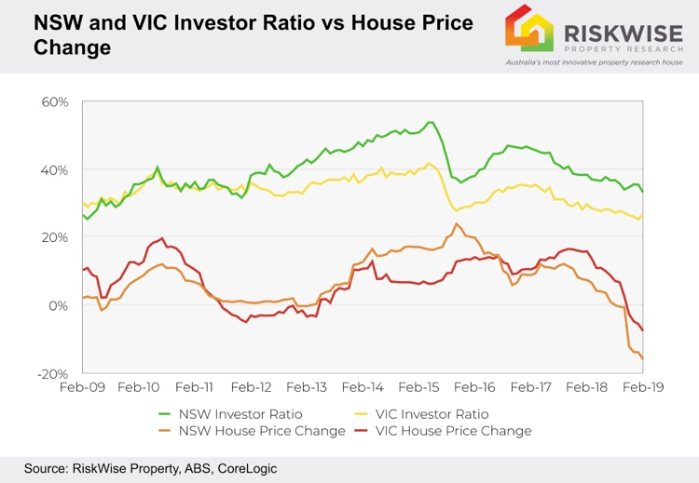

- Off-the-plan units mainly in high-supply areas carry a high level of risk. Since mid-2017, RiskWise has been warning that many areas subject to unit oversupply carry high risk of low demand and price reductions.

“This risk is very relevant to construction lenders, developers and obviously buyers, largely investors,” he said.

Prime examples include the Brisbane CBD where, even as early as June 2016 in Statistical Area Level 4 (SA4) Brisbane Inner-City, price growth was -1.8 per cent with 17,417 units in the pipeline, an addition of 24.5 per cent to the current stock.

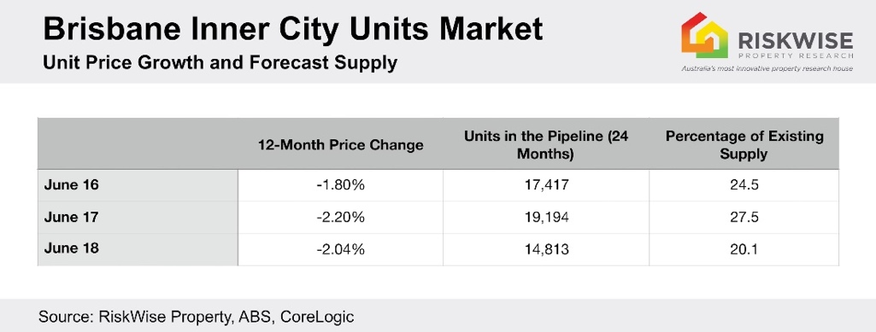

A recent analysis by BIS Oxford Economics also demonstrates that two out of three Melbourne apartments sold off-the-plan over the past eight years made no price gains or lost money upon resale, despite a property boom and record immigration.

- It’s important to listen to mainstream economists and research houses which provide accurate and up-to-date predictions. This was particularly the case from the end of 2017 when it was obvious property prices would materially decrease.

“The only question then was ‘by how much exactly?’,” Mr Peleg said. “This is a key lesson, mainly for lenders and investors, as the majority of the assets that were purchased in the past couple of years experienced material price reductions, and many of them with negative or very little equity. Obviously, in some cases poor credit decisions have been made and some investors will need a number of years to see their property value increasing to the original purchase price.

“Mainstream leading economists and research houses shared with the media the results of their analysis – the same results they provide to their clients, in most cases lenders and investment funds. They have no incentive to mislead their clients and talk the market up or down.”

Mr Peleg said any major policies must be constantly reviewed and their impact reassessed according to recent developments in the housing market. Eg Labor’s proposed changes to negative gearing did not have a visible reassessment process from when it was suggested in 2016, despite major changes in the property market.

“Policy-makers should have a proper process of challenge and feedback from mainstream bodies that research the market, especially if that research is saying the implications could be adverse,” he said.

- Affordable areas show more resilience than the top end of the market.

This can be demonstrated using CoreLogic’s latest Quarterly Economic Review from February which showed despite a 7 per cent fall across Melbourne for the last three months of 2018, the bottom end enjoyed a 0.5 per cent increase.

Also, in the past 12 months houses in the lucrative areas of the Eastern Suburbs of Sydney have fallen by 10.9 per cent and the Inner-East in Melbourne by 18.8 per cent.

“Investors or owner-occupiers with low equity have to reconsider purchasing a property at the top end of the market as they could suffer from high volatility in the short term.

“For example, if you plan to refinance or sell and move to another property in three to five years expecting strong capital growth, this could be significantly impacted by major economic events. However, the lower end is by far less volatile and generally less subject to such strong market movements.”

Visit www.riskwiseproperty.com.au
ENDS

About RiskWise:
RiskWise Property Research was formed in 2016 with the goal of providing property risk advise and research services to help its clients make informed purchasing decisions.
Its goal is to provide private investors, home buyers, property professionals and institutional clients with detailed risk information to support smarter decision making. Its vision is to be a global leader in property risk rating and research helping its clients to achieve deeper risk insights so they can make smarter property investment decisions.
Visit www.riskwiseproperty.com.au

To organise an interview with RiskWise CEO Doron Peleg please contact:
Vanessa Jones
Media & Communications Manager, RiskWise Property Research
Australia’s most innovative property research house
0421 057 129 | Vanessa.Jones@riskwiseproperty.com.au |
www.riskwiseproperty.com.au | Queensland, Australia

