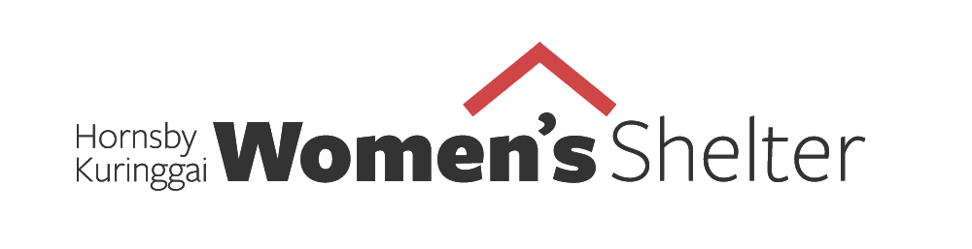
MEDIA RELEASE 30 November, 2020

Speak Out, Save Lives to help prevent violence against women: 16 Days of Activism Against Gender Based Violence, from 25 November - 10 December

Hornsby Ku-ring-gai Women's Shelter is excited to announce "Speak Out, Save Lives" - a campaign to raise awareness and funds for the prevention of violence against women in alignment with the global 16 Days of Activism Against Gender Based Violence, (25 November - 10 December).

Speak Out, Save Lives headed by HKWS President Louise McCann and Ambassador Elysse Morgan host of ABC's The Business, invites businesses, schools and individuals in our community to take part in a worldwide call for the elimination of gender-based violence.

HKWS aims to raise $89,100 in this 16 Days which will go towards our operating costs and enable us to continue working with the most vulnerable women in our community.

HKWS has developed a range of tools for participants including webinars, podcasts and online material. We can also provide speakers to present at your event to raise awareness about the role we can all play to prevent family and domestic violence.

Ms McCann said the COVID-19 pandemic exacerbated risks for women who face violence in their homes, including unemployment, financial uncertainty and confinement because of social isolation and distancing.

“The chances are that everyone knows someone who has been affected by family or domestic violence,” Ms McCann said.

“With the support of our community we can create change and work towards a world where there is no need for services such as HKWS.

“By promoting awareness about gender-based violence and looking out for the signs that someone might be experiencing domestic violence, we can help prevent and reduce the incidents of violence.”

HKWS Ambassador and Management Committee member Elysse Morgan encouraged businesses and companies to get involved by hosting events to raise awareness about family and domestic violence.

“Violence against women is a workplace issue,” Ms Morgan said. “Business can play a significant role in promoting respect and gender equality to drive cultural and societal change.

“Business leaders should speak out more about domestic and family violence and its impact on wellbeing and productivity in the workplace.

“We encourage you to join our community and use activism to advocate for women fleeing domestic and family violence.”

Statistics

- 1 in 3 Australian women (30.5%) has experienced physical violence since the age of 15;
- 1 in 5 Australian women (18.4%) has experienced sexual violence since the age of 15.3;
- 1 in 3 Australian women (34.2%) has experienced physical and/or sexual violence perpetrated by a man since the age of 15. (Australian Bureau of Statistics (ABS) 2017. Personal Safety Survey, Australia, 2016, ABS cat. no. 4906.0. Canberra: ABS).

Workplace

- 94% of employees believe employers should take a leadership role in educating their workforce about respectful relationships between men and women (White Ribbon, 2018);
- 19% of Australian workers who had experienced domestic violence reported the harassment continued at their workplace (Australian Bureau of Statistics, 2011);
- The wellbeing and productivity of workplaces can be significantly impacted by the consequences of domestic violence, especially through absenteeism and presenteeism, with the cost to employers in 2021-22 projected to be $235m (Australian Human Rights Commission).

Media contact
Marianna Papadakis
marianna@hkws.com.au

