PRESS RELEASE
4th December, 2017

Ever wondered how dirty your computer keyboard is?

New research indicates that your humble computer keyboard may be harboring more bacteria than a toilet seat, and just may be making you and others sick…

The concern for the spread of infectious diseases has never been higher in Australia, and rightly so. In 2017 we have seen the worst flu outbreak on record and have experienced increasingly high levels of gastro outbreaks across workplace environments ^{[1]}.

More than two and a half times the number of laboratory confirmed notifications of influenza have been reported to the National Notifiable Diseases Surveillance System (NNDSS) this year when compared with the same period last year ^{[1]}.

Similarly, in NSW gastro outbreaks are 120 per cent higher across some intuitions, more than double, than the previous five year weekly average number of outbreaks for August ^{[2]}.

According to many health studies, including studies conducted by the Centre of The Centers for Disease Control and Prevention in the U.S, 80% of all cross contaminations are transmitted by hands and touch ⁽³⁾. This is supported by the World Health Organisation (WHO), who assert that “hands are the main pathways of germ transmission” ^{[4]}.

It’s not surprising then, that one of the worst pieces of equipment for harboring bacteria and viruses is the humble computer keyboard.

Research from the Swinburne University of Technology studied the amount and type of bacteria on personal faculty keyboards and shared keyboards and other surfaces around the University. They found that keyboards can have high levels of bacteria on them and that shared keyboards tend to have more bacteria than those used by only one person ^{[5] [7]}.

What’s even more disturbing, research conducted by the University of Arizona also found that the average desktop has 400 times more bacteria than the average toilet seat. That study took samples from offices across the United States, with research also showing that women’s desks tended to harbor more bacteria than men’s ^{[5] [7]}.

A study at Chicago’s Northwestern Memorial Hospital found that two deadly drug-resistant types of bacteria (vancomycin-resistant Enterococcus faecium (VRE) and methicillin-resistant Staphylococcus aureus (MRSA)) could survive for up to 24 hours on a keyboard, while another common but less deadly bug (Pseudomonas aeruginosa) could survive for an hour ^{[6] [7]}.

One of the greatest challenges is how to effectively clean and disinfect your computer keyboard and mouse.

Majac Healthcare has recently introduced a new state-of-the-art keyboard to Australia that has been heralded as the world’s easiest keyboard to keep clean.

The ICONA Super-Clean Infection Control Keyboard has been designed with an all-glass keyboard surface. It has a smooth-touch exterior with no gaps or crevices for bacteria to hide. It has typing vibration and sound options, employs Bluetooth technology, and is lightweight and super strong. Unlike other keyboards on the market, the Super-Clean Keyboard is extremely user friendly, practical to use and is 100% waterproof. The user can spray and wipe the surface easily and regularly with all sorts of cleaning and disinfecting liquids.

What’s more, the keyboard has rendered the mouse, which can also collect significant amounts of bacteria, as obsolete. The Super-Clean Keyboard has adopted the latest smart-tech design allowing the user to have mouse functionality by simply placing two or more fingers on the glass keyboard screen at the same time and moving them directionally.

James Keogh, Company Director at Majac Healthcare asserts, “It’s widely known that keyboards used at home and in the workplace become awfully dirty. You only have to turn the one you use regularly upside down to see the sort of grime it can harbor.” Majac Healthcare believes that infection control can be greatly improved with the adoption of the keyboard and the introduction of sound cleaning practices. “The Super Clean Keyboard won’t collect any dirty particles and you can easily spray and wipe the keyboard regularly. This will significantly reduce the risk of cross contamination of bacteria and viruses” Mr Keogh said. “We believe the unit will have a huge impact on reducing the spread of illness at home, in workplaces, and importantly, in healthcare facilities.”

The Super-Clean Keyboard retails for only $249.00 (Inc GST) from Majac Healthcare: www.majacmedical.com.au

ENDS…

Product information:
http://www.majacmedical.com.au/product/icona-super-clean-waterproof-keyboard/
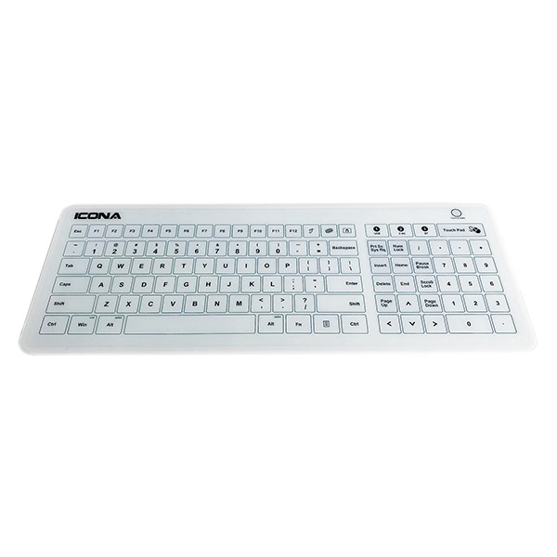
References:
- http://www.health.gov.au/flureport
- http://www.health.nsw.gov.au/news/Pages/20170901_01.aspx
- https://www.cdc.gov/healthywater/hygiene/fast_facts.html, http://www.who.int/csr/disease/ebola/one-year-report/factors/en/
- http://www.who.int/gpsc/5may/Hand_Hygiene_Why_How_and_When_Brochure.pdf
- Anderson, G; and Palombo, EA, Microbial contamination of computer keyboards in a university setting; American Journal of Infection Control, 37(6) pp.507-9, 2009.
- Lankford, MG; Collins, S; Youngberg, L; Rooney, DM; Warren, JR; and Noskin, GA, Assessment of materials commonly used in health care: Implications for bacterial survival and transmission. American Journal of Infection Control, 34(5)pp. 258-63, 2006.
- http://www.center4research.org/bacteria-computer-keyboards-toilet-seats/

About Majac Healthcare:
Since 2001, Majac Healthcare has provided innovative and world-class products to the medical, dental, and health related sectors in Australia and New Zealand. Through the provision of committed service support and leading product solutions, we aim to deliver the best quality patient care and enhanced practice management and profitability. Education and integrity is central to the way we operate – we apply only the best evidence-based research and science in our education and product offering. We provide an extensive range of products from some of the world’s best brands. All share common factors – they are of the highest quality, meets all required Australian, New Zealand and European Standards, and are competitive in their pricing.

Contact:
James Keogh – Company Director
E: james@majacmedical.com.au
Ph: 1300 138 578
W: www.majacmedical.com.au

