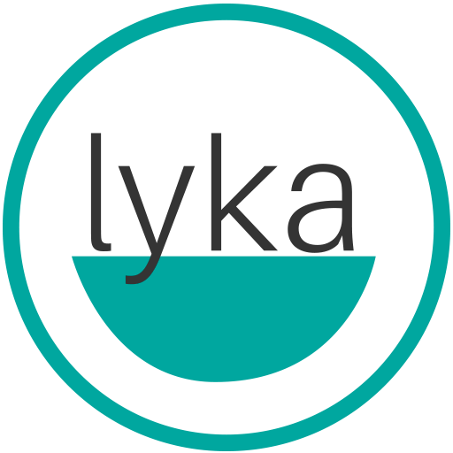

Lyka Pet Food Crowns the Winner of The First Australia’s Most Lykable Dog Competition, Helps Two Shelter Dogs Find Fur-ever Home

SYDNEY (May 16, 2019) – Lyka Pet Food’s search for Australia’s Most Lykable Dog has officially come to a close, with the announcement of the winners on May 15, 2019, Wed. at 8 am. Sean the Tibby Pug won the first place prize of a year supply of Lyka dog food, tailored specifically to (dog name)’s needs.

On the 13th of March 2019, Lyka set out to find Australia’s most #Lykable dog and received over 500 entrants in the competition. “ We are truly grateful for the wonderful response we received about the competition and we couldn’t have succeeded without our partners at the SeqK9 shelter,” says Lyka Founder and CEO Anna Podolsky.

One winner, Sean the Tibby was chosen by judges Owen George of GC Mag, Agnes Beugnon of Australian Dog Lover Magazine, and Podolsky, along with four runners-up. The four runners up were: Miesha the Greyhound, awarded Australia’s Most Popular Dog 2019, and Miles the Cavoodle, Jack the perfect poser, and Rosco the curious boxer. The runners-up will receive 1 month of Lyka pet food.

The competition successfully helped two shelter dogs Eddie, and Layla find their home. Pam Whitwell from SeqK9 Dog Shelter, who was particularly fond of Eddie, said “Eddie came into seqk9 rescue from Maryborough pound. He received some amazing training whilst in care and to see him adopted to a lovely family is a joy all foster carers know well. We wish Eddie all the best and hope that all rescue dogs get a second chance.”

Podolsky hopes the competition will grow in the future and give Lyka a chance to provide quality healthy dog food to more pet owners.

To learn more about the #Lykable dog competition and Lyka Pet Food, please visit https://lyka.com.au/.

About Lyka Pet Food:

Lyka Pet Food was started in 2018 by former management consultant Anna Podolsky, to bring the health benefits of feeding human-grade pet food to all dogs.

In 2015, when Anna’s border collie cross Lyka was only 5 years old, she was losing fur, getting bald patches, itching with allergies, low on energy, and had tooth decay bad enough for a vet to recommend tooth removal. After conducting some initial research, Anna switched Lyka’s diet from premium brands of commercial pet food to a real food diet.

Within months, all of Lyka’s issues subsided, and she was back to her happy, healthy self. Anna believes all dogs have the right to a real food diet - and founded Lyka in 2018, to provide just that.

As Lyka’s founder and CEO, Anna is committed to leading the change toward health-focused, fresh foods for pets - challenging the outdated modes of practice in the industry, and redefining pet food.

