Have voters become immune to fear-based political spin?
Cubery Australian federal election advertising review
15 May 2019

Recent reports suggest that Clive Palmer and the United Australia Party are outspending the other major political parties – combined – by a staggering ratio of 2 to 1. But while much of the commentary in the media and advertising world has surrounded the eye-watering levels of spend, not enough attention has been placed on the creative vehicle being deployed to deliver these messages.

Cubery, a tech-based research and insights company specialising in advertising effectiveness, tested the creative performance of the major parties’ advertising using its proprietary methodology. The goal was to understand what tone of voice works best and which party’s advertising was the most effective. The research identified 4 key learnings.

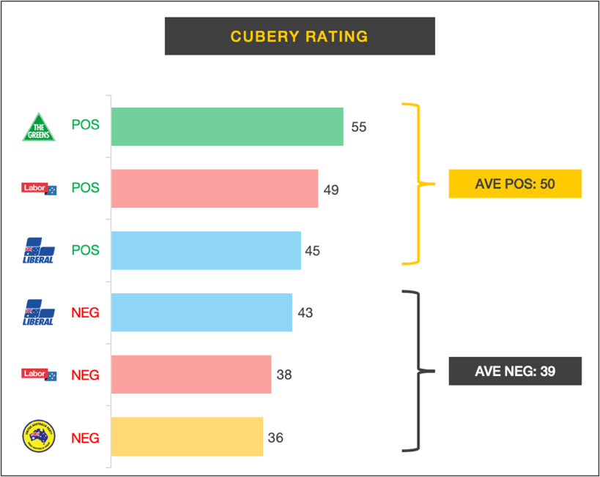
Caption: We tested 6 separate groups of advertising, isolating the positive and negative creative approaches being taken by the major parties.

1. Uplifting trumps fear
Labor’s hopeful and optimistic pitch promising “A Fair Go For Australia” was a galvanising call to middle Australia. It was effective because it projected a warm and family-oriented feeling, complimented by a clear and compelling vision for the future of Australia.
- Viewer comment: “Family orientated, makes Bill Shorten look like a regular Australian that knows what it’s like for middle class families to experience stress in life”

Video: https://www.youtube.com/watch?v=Rf7jO8lAtyE

The Liberal’s attempted to tap into our psychological resistance to change, reminding Australians about the importance of maintaining positive momentum behind the economy during these uncertain times. This was seen to be lacklustre, offering a familiar and predictable narrative, absent of anything new.
- Viewer comment: “They are really boring and don’t explain much”

Video: https://www.youtube.com/watch?v=80pwWWZwMKc

2. Leverage humour
The Liberal party’s incessant attacks on Bill Shorten and the Labor party’s tax policies proved effective. The ruthless consistency of campaigning under the strapline “The Bill Australia Can’t Afford”, translated through to a high level of clarity in messaging and strong branding. In addition, the animated depiction of Bill Shorten as Pinocchio to highlight his lies and broken promises, struck a chord with viewers.
  - Viewer comment: “The puppet was hilarious; it made me smile”

Video: https://www.youtube.com/watch?v=XdfAdMus0rM

3. Care-mongering not scare-mongering
The Greens’ tone of voice was constructive and uplifting, with voters’ perceiving the messaging to be by far the most informative and trustworthy out of all the parties. By engaging voters in an open and transparent way, The Greens’ campaign was found considerably more interesting than advertising for the other parties.
- Viewer comment: “Ads focussed on real issues, things that matter”

Video: https://www.youtube.com/watch?v=j5ULXUPCNM8

4. Make it clear what you stand for
Clive Palmer’s UAP took the mantle as the most ineffective campaign of all the major political parties. The ads didn’t contain enough substance and clarity around the party’s policies and positioning, to overcome the negative filter people see Clive through. As a result, they didn’t strongly persuade people to vote for the party.
- Viewer comment: “They were utterly non-specific in how they would deliver all of these jobs and ‘securing our children’s future’, making them a waste of time and money”

Video: https://www.youtube.com/watch?v=x2MztV4wH5Q

Read the in-depth results on Cubery’s blog: https://cubery.com/blog/advertising/have-voters-become-immune-to-fear-based-political-spin/

Research Methodology:
We looked at a broad spectrum of federal election advertising across both online and offline channels. We created 6 separate groups (with each group containing 3 executions) covering the general approach(es) being taken by each of the parties.
- Liberal (Positive/Constructive)
- Liberal (Negative/Fear)
- Labor (Positive/Constructive)
- Labor (Negative/Fear)
- UAP (Negative/Fear)
- Greens (Positive/Constructive)

We recruited a nationally representative sample of n=100 people per group who are voting in the upcoming federal election, and measured creative effectiveness using Cubery’s proprietary methodology. Results were benchmarked versus our normative databases.

---
About Cubery:
Cubery provides end-to-end solutions for testing marketing effectiveness, combining the power of research automation with a team of specialist consultants. Expert-led consumer insights are available for as little as $1,500, with results delivered from just 24 hours.

Company: Cubery Pty Ltd
Website: https://cubery.com/
Media Contact: Angela Diamant, angela@cubery.com, +61 451 307 901

