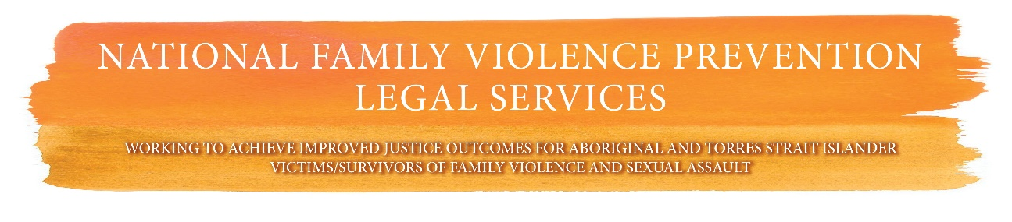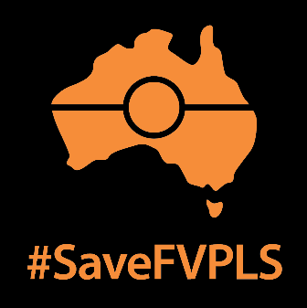



Friday 6 December 2019

**FUNDING CUTS SILENCE ABORIGINAL AND TORRES STRAIT ISLANDER WOMEN**

The Federal Government’s decision to cut funding to the National Family Violence Prevention and Legal Services Forum (National FVPLS) from June 30, 2020 will remove Aboriginal and Torres Strait Islander women’s voices from the national stage.

The National FVPLS Forum is the only national peak body for Aboriginal and Torres Strait Islander victim/survivors of family violence and sexual assault.

The National FVPLS Forum supports and advocates on behalf of the thirteen member organisations who work on the frontline of family violence against Aboriginal and Torres Strait Islander women and their children.

Chair of the National FVPLS Forum Antoinette Braybrook says: “Yet again we are forced to fight to get our funding back. This not only drains our already limited resources. It rips Aboriginal and Torres Strait Islander women’s voices out of critical national conversations.”

Rosie Batty, AO, a prominent campaigner on domestic and family violence says: “The Voices of women and children have never needed to be heard more than now”. Ms Batty says the government’s decision to cut funding to the National FVPLS Forum says “we don’t want to hear you”.

The government claims this decision stems from the CDU evaluation of the forum. This is incorrect. The recommendations contained in that evaluation point to the urgent need for increased resources for National FVPLS.

 “The Government’s decision is not only baseless and unjustified. It is an attack on our self-determination,” says Phynea Clarke, Deputy Chair of the National FVPLS Forum. “It was cruel irony to receive the news we would be defunded on 25 November International Day for the Elimination of Violence Against Women.”

Labor MP Linda Burney, the first Aboriginal woman to be elected to the Australian House of Representatives, says: “I am completely astounded when you look at the shocking statistics relating to Aboriginal women and family violence”. “It beggars belief that this would happen.”

Aboriginal and Torres Strait Islander women nationally are 34 times more likely to be hopsitalised for family violence and 10 times more likely to die from a violent assault than other women in this country.

The National FVPLS Forum calls on the newly established National Indigenous Australians Agency (NIAA) to reinstate its annual funding of $244,000 and provide additional much-needed resources.

Follow #SaveFVPLS on Twitter and Facebook.

**Media Contact: Alice Dowling, 0408 812 830 or** [**eo@fvpls.org**](mailto:eo@fvpls.org)